NAME OF YOUR PROJECT GOES HERE, CENTERED, IN ALL CAPITAL LETTERS USING 12 POINT SARIF FONT SUCH AS TIMES NEW ROMAN OR CAMBRIA. YOU MAY USE MULTIPLE LINES IF NECESSARY BUT LINES MUST BE DOUBLE-SPACED
by
Student Name
A project report/thesis submitted in partial fulfillment
of the requirements for the degree
of
MASTER OF SCIENCE
in
Computer/Electrical Engineering
Approved:

Major professor’s name
Major Professor

Committee member’s name
Committee Member

Committee member’s name
Committee Member
WEBER STATE UNIVERSITY
Ogden, Utah
Year

DEDICATION
The Dedication page is optional and follows the Title Page. Preliminary pages which precede the Table of Contents, include the Dedication, are not displayed in the Table of Contents. The heading is the same as other major [first level] headings in the project report/thesis. The text in the Dedication is limited to one page and is in the same font size and style as the other text in the project report/thesis.

TABLE OF CONTENTS
Page
LIST OF FIGURES iv
LIST OF TABLES v
NOMENCLATURE vi
ACKNOWLEDGMENTS vii
ABSTRACT viii
CHAPTER 1. INTRODUCTION: FORMATTING 1
Typeface and Spacing. 1
Margins and Page Numbers. 1
Figures. 2
Tables. 3
Equations. 3
References. 3
Appendices 4
Paper 4
Second Level Heading 4
Third Level Heading 4
Fourth level heading 5
Fourth level heading for APA. 5
Fifth level headings 5
Fifth level heading for APA. 5
Landscape Pages 7
Bibliography 11
APPENDIX A. [INSERT APPENDIX TITLE HERE] 12
Second Level in an Appendix 12

LIST OF FIGURES
Page
Figure 1.1 The Link to Previous and Page Number items 7
Figure 1.2 The design and format tools are also very useful for adjusting the page numbering. 8
Figure 1.3 Example – Use this page if you have a figure in landscape orientation. 9
Figure A.1 This figure illustrates how to use the multilevel list feature to trigger figure naming convention changes, such as adding letters instead of numbers to the leading label in an appendix. 12

LIST OF TABLES
Page
Table 1.1 Example – Use this page if you are using a table in landscape orientation. 10

NOMENCLATURE
GMO Genetically Modified
HAZ-MAT Hazardous Material
MO Modus Operandi
PBJ Peanut Butter and Jelly
TBD To Be Determined
VIP Very Important Person

[The nomenclature for your project is optional. This list may be placed in the following places: as the last preliminary page, before the Reference section, or as an Appendix. The heading is bold if other major headings are bold, and the list is in the same font size and style as text.]

ACKNOWLEDGMENTS
[The Acknowledgements page is optional and limited to four pages. It precedes the Abstract page. Heading is bold if other major headings are bold. It is in the same font size and style as text, and the vertical spacing, and paragraph style margins are the same as used in text. Use complete sentences.]
Sample Wording
I would like to thank my committee chair, __________, and my committee members, __________, __________, __________, and __________, for their guidance and support throughout the course of this research.
In addition, I would also like to thank my friends, colleagues, and the department faculty and staff for making my time at Weber State University a positive experience.
Acknowledgments

ABSTRACT
[The text of the Abstract starts two double spaces below the major heading. The text of the Abstract is double-spaced or space-and-a-half according to the spacing style of the text of the project report/thesis. Follow the same margin settings as your narrative text. The page number (lower case Roman numeral) should be placed at the top center of the page.
Your Abstract must be a “complete snapshot” of your manuscript and be a stand-alone piece. Since the text of the Abstract may be distributed widely through a variety of databases, formal citations, images, and complex equations should not be included. Paragraph one introduces your specific problem and the methods used. The remaining paragraphs present the research and results in detail.

INTRODUCTION: FORMATTING
New chapters always start on a new page – this is built into the headings. Major headings (Heading 1 in the Styles ribbon) consist of the chapter designation (e.g. CHAPTER 1, automatically added) and the title. They are centered, bold, and in all capital letters (do not use the font -> UPPERCASE, instead see Chapter 2, Adjusting Capitalization). Number chapters using Arabic numbers. Avoid excessive white space on your pages. There should be no more than one-quarter to one-third of a page that is blank.
Paragraphs of the body text are all indented (this is set in the “Body” Style from the Styles ribbon). Text is double spaced. Being consistent is very important in formatting your project report/thesis. Use the same formatting basics in all the chapters. Always leave at least two lines of text at the bottom of a page or at the top of a page. If it is less than two lines, then force a page break earlier.

Typeface and Spacing.
Text should be 11-point or 12-point in a serif font (e.g. Times New Roman or Cambria). Line spacing should be double. Typeface, size and spacing should be consistent throughout the document. Major sections should be titled using Heading 1. Subsections should be titled using subsequent heading numbers (2, 3, etc.).

Margins and Page Numbers.
All margins except for the binding edge should be 1”. The binding edge (left margin) should be 1.5”. Each page (except the cover page and the appendices) should be numbered in the bottom margin. The page number may be centered or justified on the side opposite the binding edge. Page numbers should either be a single page number or a section number and a page number separated by a dash. Lower case Roman numerals are allowed on introductory pages.

Figures.
To practice adding a caption and number to the figure above, please do the following. Right click on the figure and choose “Insert Caption.” Ensure that the “Exclude label from caption” box is unchecked. Then click on “Numbering.” Check “Include chapter number.” Under the “Chapter starts with style” dropdown choose “Heading 1.” Under the “Use separator” dropdown choose “(period)”. Click “OK.” Type “WSU campus.” in the caption box then click “OK.” Update the figure numbers throughout the document by hitting Ctrl-A, then F9. Each figure should be labeled with (a) the word Figure, (b) the figure number, (c) a period and (d) a descriptive caption. Captions should be clear and concise. Captions should describe the data shown or draw attention to important features in the figure. Figure labels should be located below (or in rare circumstances involving multiple figures, beside) their respective figures.

Tables.
All tables should be numbered, either with a single table number or with a section number and a table number separated by a dash. Table numbers should increment with each table in the section or document. Each table should be labeled with (a) the word Table, (b) the table number, (c) a period and (d) a title. Table labels should be located above their respective tables.

Equations.
All equations should be numbered, either with a single equation number or with a section number and an equation number separated by a dash. Equations should appear centered, inline with the text but with extra space above and below. Equation numbers should appear on the first line of each equation, right-justified and in parentheses. Variables should be written in italic both in equations and in the text.

References.
All references in the bibliography should be in IEEE format. Please practice adding a reference via the following steps. First, click on the “References” menu. Then choose “Manage Sources.” Click “New.” Under “Type of Source” choose “Journal Article.” Add the information from the following journal article to the appropriate fields: A. Chatterjee, J.M. Jin, J.L. Volakis, "Computation of cavity resonances using edge-based finite elements", IEEE Transactions on Microwave Theory and Techniques, vol. 40, no. 11, pp. 2106-2108, 1992. Multiple authors are separated by a semicolon as follows: Chatterjee, A.; Jin, J. M.; Volakis, J. L. Next, insert a citation. Click on the place in the document where you want the citation to occur. The click on “References” menu and click on the “Insert Citation” dropdown. Click on your article. Update citation numbers throughout the document by hitting Ctrl-A, then F9. Note that your article has been added to the Bibliography section.

Appendices
Appendices should be labeled using capital letters starting with A. Each appendix should be introduced with a page containing only the word “Appendix”, the appendix letter and a brief description of its contents. Pages in the appendices need not be numbered, but if they are, each page number should consist of the appendix letter and a page number separated by a dash.

Paper
All theses and reports should be submitted both as a .PDF and a hard copy. The hard copy should be printed on acid-free, good quality bond paper with a rag or cotton content of at least 25%.

Second Level Heading
Second level headings (Heading 2 in the Styles ribbon) are bold, centered, and the first letter of each word is capitalized, except single-syllable conjunctions and prepositions [and, with, respectively].

Third Level Heading
Third level headings (Heading 3 in the Styles ribbon) are bold, not indented, and the first letter of each word capitalized, as with second level headings. If the chapter title or heading is longer than one line, use single spacing between the lines of the title (this is built into the style). Use same font size as other major headings (and bold if other major headings are bold). Be consistent with spacing between chapter title and text for all chapters (this is set in the styles).
Do not leave sub-headings alone at the bottom of a page without any text following it. You must have at least two lines of text. If necessary, leave extra space at the bottom of the page and place the sub-heading on the next page. This is also set by the heading style by default, and can be adjusted there for ease.

Fourth level heading
Fourth level headings (Heading 4 in the Styles ribbon) are bold, indented, and only the first word is capitalized.

Fourth level heading for APA.
This is an inline heading which makes use of the Style Separators. Your department may require this style of heading for conformity to APA guidelines. See Chapter 3 for more information on Style Separators. If you use the navigation tab, this may not function as you expect when you utilize the hidden paragraph marker technique. Alternatively, using the Style Separator will allow the heading to appear in the navigation pane properly.

Fifth level headings
Fifth level headings (Heading 5 in Styles ribbon) are bold, italicized, indented, and only the first word is capitalized.

Fifth level heading for APA.
The fourth, fifth, and sixth style constraints are optional, but generally represent the APA headings suggestions, modified to associate them up with one level up to accommodate the special level one headers.

Sixth level heading
Sixth level headings (Heading 6 in the Styles ribbon) are italicized and indented and only have the first word capitalized. These deeper levels of headings do not necessarily need to be included in the Table of Contents. The sixth level heading should also be inline if the fourth and fifth levels headings are inline with the text.

Landscape Pages
Landscape pages cause many issues. One type of issue is the layout and section breaks may cause margins to change. Pay attention that when you adjust the left margin for portrait pages that you make the same change to the top of the landscape pages, and revert the left margin back to 1”. Another common issue is page numbering. Figure 1.1 shows the location of the Link to Previous and Page Number buttons. There are also some design tools which are necessary to adapt the built-in page numbering to the standard centered position, rotated text orientation, shown in Figure 1.2. To change layouts, first insert a section break by going to the Page Layout tab -> Breaks -> Section Break -> Next Page. Then you can adjust the section to landscape, adjust your margins, and then add page numbers. Consult an external reference or see a writing consultant if you are unable to complete this process – it is a necessary part of formatting.
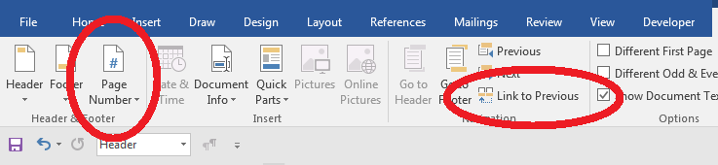
Figure 1.1 The Link to Previous and Page Number items
are important tools for numbering landscape pages properly
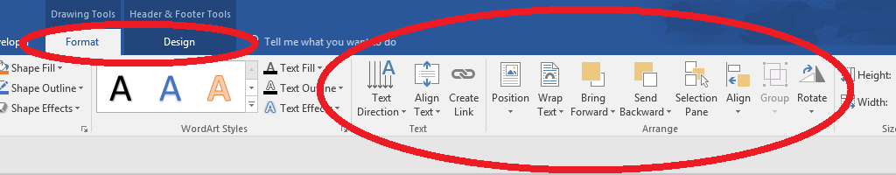
Figure 1.2 The design and format tools are also very useful for adjusting the page numbering.
There is a style of page number which places the page number on the right but it needs to be adjusted. On the other hand, you can insert a section break (new page), then paste these pages in, and then adjust the numbering if necessary. The link to previous button will help you change numbering styles between sections (un-check this when you switch layouts) and the page numbering will be adjusted to “continue from previous section.” You can always test print a page of ipsum lorem to check for margin and page number alignment across sections. Always double check your page numbers when you are finished transitioning back to a portrait layout. Also, be sure your graphics and tables do not exceed the margin limits.
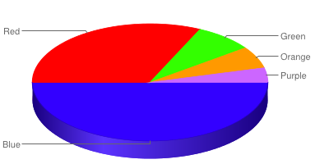
Figure 1.3 Example – Use this page if you have a figure in landscape orientation.
The page number must be to the left (what would be the bottom when your paper is all orientated as portrait.) You may need to adjust the numbering to get the correct page number for your document.
Table 1.1 Example – Use this page if you are using a table in landscape orientation.
The page number must be to the left (what would be the bottom when your paper is all orientated as portrait.
 | Column 1 | Column 2 | Column 3 | Column 4 | Column 5
Row 1
Row 2
Row 3
Row 4
Row 5
Row 6
Row 7

Bibliography
There are no sources in the current document.

[INSERT APPENDIX TITLE HERE]
[Insert Text Here. Delete Page if Not Needed.]
[Use letters to indicate Appendix sections. If you only have one Appendix, you do not need to give it a letter. It can just say APPENDIX.]

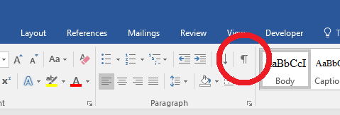
Figure A.1 This figure illustrates how to use the multilevel list feature to trigger figure naming convention changes, such as adding letters instead of numbers to the leading label in an appendix.

Second Level in an Appendix
The heading levels should all work properly in an appendix, should they be required.

