Spring 2019 Book List
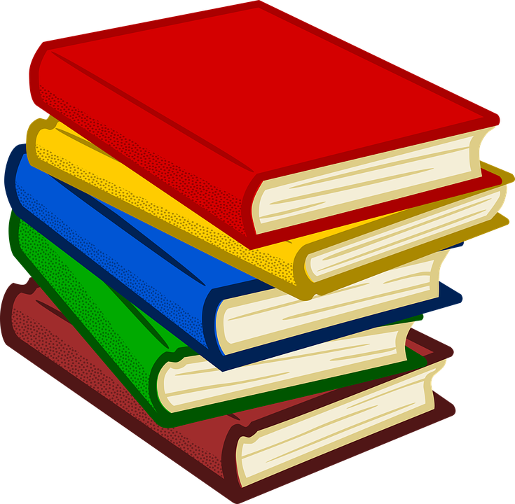

Algorithms of Oppression by Safiya Noble, Non-Fiction/Diversity
All the Things We Never Knew by Sheila Hamilton, Biography/Memoir
Cloudstreet by Tim Winton, International Fiction
Creating Wicked Students by Paul Hansedt, Non-fiction/Education
The Escape Artist by Brad Meltzer, Fiction/Thriller
First Man byJames R. Hansen, Non-fiction/Biography
Great Expectations by Charles Dickens, Classic Fiction
The Power of Moments by Chip and Dan Heath, Non-fiction
Reading with Patrick by Michelle Kuo, Non-fiction/Memoir
Rebel Talent by Francesca Gino, Non-fiction
The Romanov Sisters by Helen Rappaport, Non-fiction/Biography
Saints for All Occasions by J. Courtney Sullivan, New Fiction
Science Blind by Andrew Shtulman, Non-fiction
Sing, Unburied, Sing by Jesmyn Ward, Fiction
The Social Neuroscience of Education by Louis Cozolino, Non-fiction/Education
The Sun Also Rises by Ernest Hemingway, Classic Fiction

