Smartphone-Based Engineering Measurement Labs
Randy C. Hurd
Department of Mechanical Engineering – Weber State University

Introduction

Both theoretical and hands-on lab instruction are critical elements in effective engineering education. Among the most important objective of lab-based instruction is familiarizing engineering students with instrumentation and measurement techniques [1]. This learning objectives is achieved in many engineering programs through a dedicated course on “Mechanical Measurement and Instrumentation.” The course provides a theoretical framework for measurement theory and protocol in addition to exposing students to common measurement tools and software in a laboratory setting. Due to the expensive nature of most measurement systems, these labs usually consist of students working together in small groups, often with multiple groups using the lab space per day. While this approach has been traditionally effective, it presents unnecessary risks during a global health crisis such as the COVID-19 pandemic. This paper presents a new approach for guiding students through measurement labs in their own homes using instruments available in their smartphones.

The smartphone is a bit of a modern miracle, with the average device containing significantly more computational power than the Apollo 11 guidance computers [2]. In additional to impressive computing power, the average smartphone also houses an array of instruments including accelerometers, gyroscopes, magnetometers, barometers, microphones, cameras, etc. With a high-speed computer and a suite of modern sensors, an average smartphone has all the trappings of a engineering lab, although tapping into those sensors isn’t so simple; that’s where the app “Phyphox” comes in. Phyphox was developed at a university in Germany (RWTH Aachen) to enable educational physics experiments requiring only a smartphone. The app enables the user to tap into any instrument on their smartphone to record and export measurement data [3][4]. The app has already been used by educators around the world to help students to gain a better understanding of fundamental concepts in physics classes [5][6][7][8].

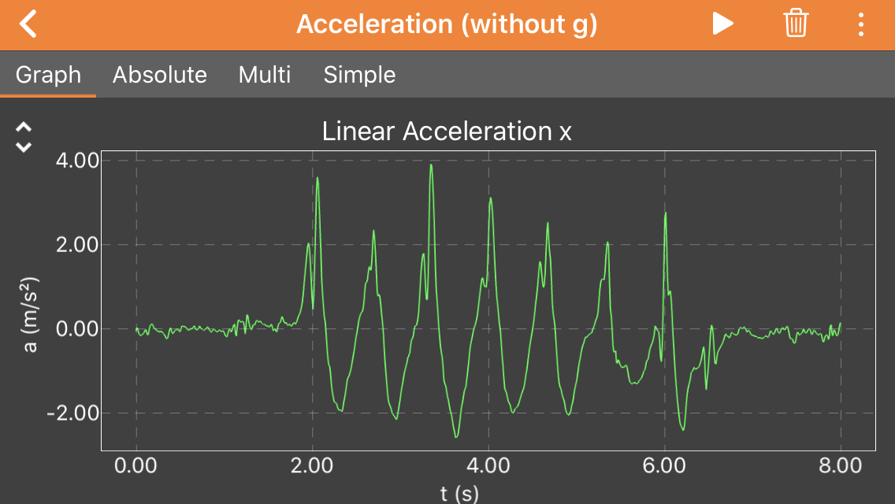
Figure 1: A smartphone screen capture while running the Phyphox app while collecting data using
an onboard accelerometer. The green peaks correspond to steps taken while holding the smartphone.
Description

While other educators have created physics labs using smartphone sensors [9][10][11][12]; these have been primarily designed to help students learn fundamental concepts in physics classes. I am not aware of any published material where smartphone sensors are employed to teach measurement techniques in an engineering context. The purpose of this project was to create two new Instrumentation and Measurement labs that students can perform at home using their smartphones, that mimic the traditional lab experience as much as possible.

Accelerometer Lab

The first lab was intended to serve as a soft introduction to several fundamental topics of the measurement course including data collection and data processing. The exercise is intended to introduce students to the world of instrumentation and measurement through an exercise that is less intimidating than later labs. In this lab, students are given basic guidelines on how to use the Phyphox app and instructed to collect accelerometer data while both walking and running over small distances. Students are asked to imagine that they work for a company developing a pedometer app and are encouraged to suggest how they might use accelerometer data as a means for counting steps. Several other questions are posed encouraging students to consider how they might use the data to calculate other parameters such as average walking speed and to consider the strengths and weaknesses of their decisions (Detailed lab information is provided in Appendix A). While this lab was designed to be introductory, it could easily be adjusted to a more advanced lab through the inclusion of more additional measurement topics such as uncertainty, signal amplification, filtering, sensor calibration, etc. Most importantly, the assignment gives students the opportunity to interact with an actual instrument to learn first-hand the unique nuances and challenges associated with collecting meaningful measurement data.

Microphone Lab

The second lab pushes the students deeper into measurement topics requiring less intuitive data collection and data post-processing. Students are instructed to drop coins on a hard surface (specifically a nickel, dime and quarter) one at a time while recording the resulting sound. Students must consider their environment when collecting this data to ensure they have adequate measurement quality (e.g. avoiding background noise, working in a room with minimal echo, etc.). Students are asked to perform a spectral analysis (frequency analysis) on the resulting data files to identify the first fundamental frequency or lowest strong tone generated by the ringing coin. This frequency is primarily a function of the coin diameter and material parameters. By measuring the first fundamental frequency of the three coins students are then asked to a) identify a mystery coin from a frequency spectrum and b) estimate the first fundamental frequency of a half dollar coin (Detailed lab information is provided in Appendix B). While the lab remains simplistic and is easily performed using only a phone and common items, the lab provides the students first-hand experience with valuable measurement fundamentals including: collecting meaningful data, processing data and using collected data to create models and make predictions.

Conclusions

This effort has shown that modern technology provides significant potential for providing students with valuable educational experiences that were previously only possibly within a university lab. The diversity of instruments and sensors in a modern smartphone provide a unique opportunity for helping students gain hands on experience collecting and analyzing measurement data, and the effort described in this report has only scratched the surface. The sensors mentioned in this article could be used for other valuable applications such as using the accelerometer to perform vibration analysis on a motor or suspension system or using microphone recordings to teach basic voice recognition algorithms. Additional sensors common to smartphones, including gyroscopes, magnetometer and barometers to name a few, could be used to create many other useful lab exercises. Additionally, inexpensive cameras have recently become a powerful measurement tool for computer vision technologies such as lane assist and face recognition. An entire class could likely be dedicated to studying the use of cameras as a measurement tool as well as the many image processing and computer vision algorithms in use today. My future efforts on this topic will likely involve creating smartphone-based experiential lab assignments for teaching students about the many ways that cameras can be used to make unique measurements.

Acknowledgements

I thank the Office of Research, Scholarship and Professional Growth at Weber State University for funding this project under their Innovative Teacher Grant for Facilitating Experiential Learning Online. I also want to thank the developers of Phyphox at RWTH Aachen for providing a valuable educational platform that was essential to the success of this project.

References
- Feisel, Lyle D., and Albert J. Rosa. "The role of the laboratory in undergraduate engineering education." Journal of engineering Education 94.1 (2005): 121-130.
- Grossman, David. “How Do NASA’s Apollo Computer Stack Up to an iPhone?” Popular Mechanics. 13 March 2017
- Staacks, Sebastian, et al. "Advanced tools for smartphone-based experiments: phyphox." Physics Education 53.4 (2018): 045009.
- Stampfer, Christoph, Heidrun Heinke, and Sebastian Staacks. "A lab in the pocket." Nature Reviews Materials 5.3 (2020): 169-170.
- Pierratos, Theodoros, and Hariton M. Polatoglou. "Utilizing the phyphox app for measuring kinematics variables with a smartphone." Physics Education 55.2 (2020): 025019.
- Götze, Benjamin, et al. "Smartphone-Experimente zu harmonischen Pendelschwingungen mit der App phyphox." PhyDid B-Didaktik der Physik-Beiträge zur DPG-Frühjahrstagung (2017).
- Ishafit, and Mentari Eka Wahyuni. "Determination The Coefficient of Restitution in Object as Temperature Function in Partially Elastic Collision Using Phyphox Application on Smartphone." Science and Technology Indonesia 4.4 (2019): 88-93.
- Pramudya, Yudhiakto, and Endra Raharja. "The influence of inclined plane angle to the oscillation period of spring and block systems." 2019 Ahmad Dahlan International Conference Series on Engineering and Science (ADICS-ES 2019). Atlantis Press, 2019.
- Martínez, Lander, and Pablo Garaizar. "Learning physics down a slide: A set of experiments to measure reality through smartphone sensors." 2014 IEEE Global Engineering Education Conference (EDUCON). IEEE, 2014.
- Ballester, E., et al. "Smart physics with smartphone sensors." 2014 IEEE Frontiers in Education Conference (FIE) Proceedings. IEEE, 2014.
- Arribas, Enrique, et al. "Measurement of the magnetic field of small magnets with a smartphone: a very economical laboratory practice for introductory physics courses." European Journal of Physics 36.6 (2015): 065002.
- Hendeby, Gustaf, et al. "Platform for teaching sensor fusion using a smartphone." International journal of engineering education 33.2B (2017): 781-789.

Appendix A – Accelerometer Lab Assignment

Objective:
The purpose of this lab is to help students become familiar with:
- Phyphox, a smartphone app for collecting measurements
- Taking measurements and collecting data
- Accelerometer characteristics
- Plotting measurement data

Instructions:
First, download the app “Phyphox” onto your smartphone and familiarize yourself with the software. Phyphox enables the user to pull data from the many sensors embedded in a smartphone. Choose “Acceleration (without g)” from the list and press the play button (triangle). This starts the data collection process. Note the recording can be paused and then deleted or exported. Click on the button with three vertical dots. This provides an option to export the raw data in a variety of formats. I recommend exporting data as an Excel file.
You will use this feature of the app to collect accelerometer data while walking and jogging (make sure your smartphone is safely secured while doing this). I recommend starting the app, holding still for a small period, walking or jogging a specified number of steps (more than five), then holding still again before pausing the recording and exporting the data.
Once the data has been transferred to your computer I recommend using Python or Matlab to clip, plot and analyze the collected data (I have a video tutorial for doing this using Python). Clip out data that is not representative of walking and running. Calculate and plot the total acceleration magnitude for the length of your recording.
Write a short lab report that shows the collected data and answers the questions below. Include plots of the x, y and z acceleration components as well as magnitude. Create a plot to compare at least some of the walking data with the jogging data.
Questions:
- How are the x, y and z accelerometer axes oriented relative to your smartphone?
(Draw a diagram)
- Assume you are part of a team creating a smartphone pedometer app.
  - What criteria might you use for counting a step?
  - Will you look at one component of acceleration, or the total magnitude?
  - What are the weaknesses of your criteria? (consider false positives/negatives)
  - How might you combat these weaknesses?
- How do the results differ between walking and running?
- Use your data to measure the time between steps, then measure or estimate your average stride length for both walking and jogging. Use these numbers to:
  - Calculate your average walking speed in ft/s and mph.
  - Calculate your average running speed in ft/s and mph.
- How might a pedometer be used to estimate distance traveled? What are the weaknesses of this measurement approach.
- Besides counting steps, how else might accelerometer measurements be used?

Appendix B – Microphone Lab Details

Objective:
The purpose of this lab is to help students become familiar with:
- Collecting acoustic data (free of excessive measurement noise)
- Spectral analysis (frequency analysis) using Fourier Transform
- Generating and interpreting spectral plots
- Scaling as a means of simple modeling

Instructions:
To perform this lab you will need three coins (nickel, dime & quarter) a hard surface and a quiet room. You will be using the “Audio Scope” function of the Phyphox app to collect the sound generated by a coin falling onto a hard surface. Before collecting data make sure you have maximized the collection duration of “Audio Scope” to 500 milliseconds. I also recommend dropping the coin nearly on its face so it rattles a bit before coming to rest on the hard surface. Repeat the process for the nickel, dime and quarter. I recommend exporting the data as a .xls file, though any format is fine. (Recording quality may be improved by collecting data under a heavy blanket).
Compute the spectral density for each of the collected data files (I recommend using Welch’s Method, signal.welch() in Python, pwelch() in Matlab). Plot the resulting spectral estimates and Identify the lowest resonant frequency (first large peak) for each coin. If we perform a dimensional analysis of a vibrating coin (assuming coins have the same aspect ratio, diameter to thickness ratio) we can derive the relationship below:
$$f=const. ∙ \frac{1}{D}\sqrt{\frac{E}{ρ}}$$
where f is the vibration frequency, D is the coin diameter, E is Young’s modulus and ρ is density. A nickel, dime and quarter all have similar composition, each being at least 75% copper with the remaining fraction nickel, thus each coin will have a similar value for E and ρ; we would expect the excited frequency to primarily vary inversely with coin diameter D. Plot the lowest resonant frequencies identified as a function of coin diameter (D values: nickel = 21.21 mm, dime = 17.91 mm, quarter = 24.26 mm). Fit a line to the data and use this linear model to predict the lowest resonant frequency for a half dollar coin (D = 30.61 mm).
Write a short lab report that shows the collected data and answers the questions below. Include the specs for the microphone on your phone, especially sample rate (these are listed for most smartphones on the Phyphox website). Include a plot of the spectral estimate for each coin, as well as a plot showing resonant frequency as a function of coin diameter with your predicted value for a half dollar coin.

Questions:
- Do you think you could use the collected data to predict the lowest resonant frequency for a penny? Why or why not?
- What applications do you think acoustic spectral analysis can be used for? What about outside of acoustics?
- Estimate the potential error of using your line fit to predict resonant frequency given a specific coin diameter? In what range would you expect the lowest resonant frequency of a half dollar exists?
- What factors might account for the data points not fitting a line more closely?
- What are the highest frequencies for your spectral estimation returned values? What do you think governs this cutoff?
- Suppose you decide to test your estimated resonant frequency for a half dollar, but are only able to find a half dollar minted before 1964 and thus 90% silver. Would you expect this coin to have a resonant frequency higher or lower than the value predicted? Why?
- What coin do you think produced the spectra below?

