Fall 2019 Book Groups
Book List
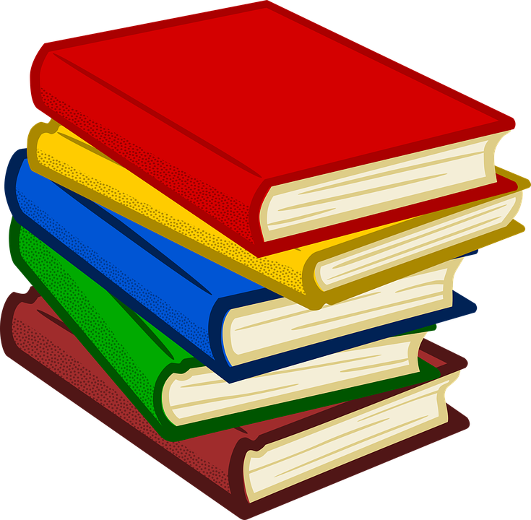

A Hope More Powerful Than the Sea by Melissa Fleming, Non-Fiction/Memoir

American Prometheus by Kai Bird, Biography

Coders by Clive Thompson, Non-Fiction/Technology

How Humans Learn by Joshua R. Eyler, Non-Fiction/Educational

In Cold Blood by Truman Capote, Non-Fiction Novel/True Crime

Incognito by David Eagleman, Non-Fiction/Psychology

Island of the Lost by Joan Druett, Non-Fiction/History

Little Women by Louisa May Alcott, Classic Fiction

Loonshots by Safi Bahcall, Non-Fiction/Business

Midnight in Chernobyl by Adam Higginbotham, Non-Fiction/History

Multipliers by Liz Wiseman, Non-Fiction/Leadership

On Looking by Alexandra Horowitz, Non-Fiction/Psychology

Radical Condor by Kim Scott, Non-Fiction/Business

The Overstory By Richard Powers/Fiction

The Worst Hard Time by Timothy Egan, Non-Fiction/History

What the Wind Knows by Amy Harmon, Historical Fiction

Where the Crawdads Sing by Delia Owens, Non-Fiction/Historical Fiction

Where the Forest Meets the Stars by Glendy Vanderah/Fiction

