SOP: Reports
Pull various data points through automated reports

- Find “Reports” tab on top right header in green:

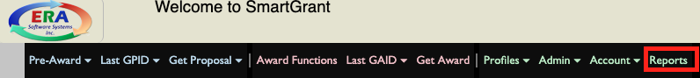

Proposal Reports
Pull various data points on proposals entered
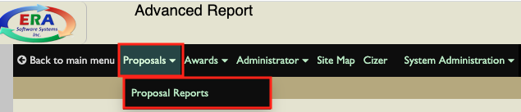

Current reports available: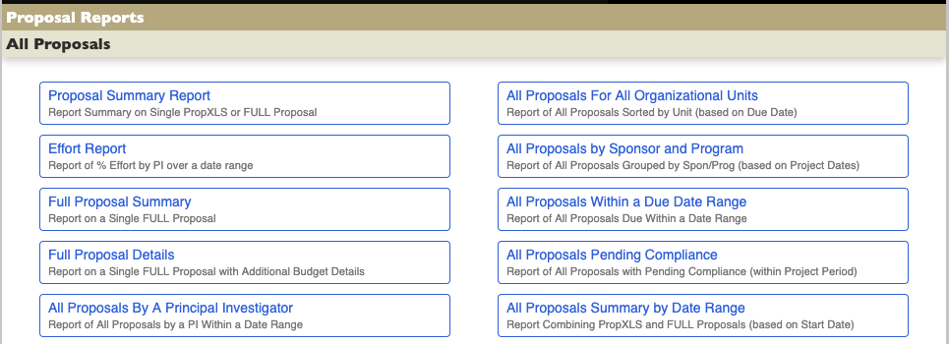

Award Reports
Pull various data points on awards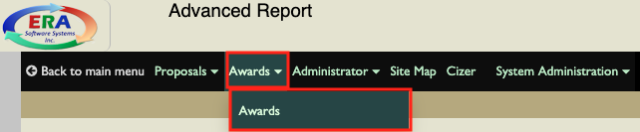

Current reports available:
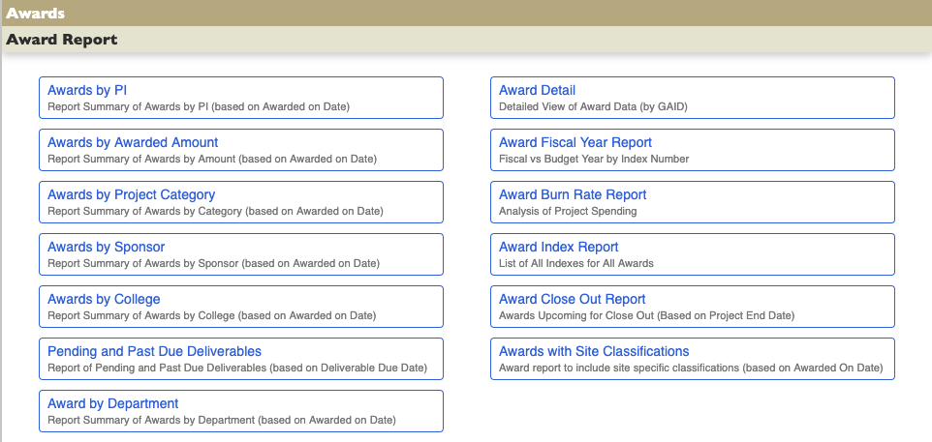

Profile Reports
Pull various data points on institution information, like department, college, or PI activity
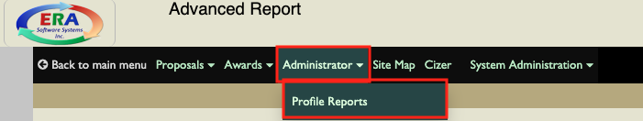

Current reports available:
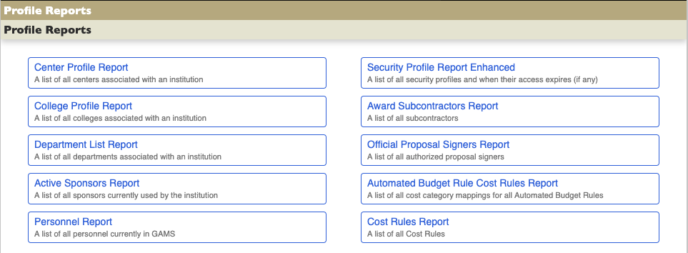
- Depending on type, report with prompt parameters, like specific GAIDs or date range.
  - Enter relevant information—click “View Report”
  - To save as excel:
