PropXLs PROPOSALS & AWARDS
Entire workflow for entering a proposal in Pre-Award, then managing an awarded project in Post-Award

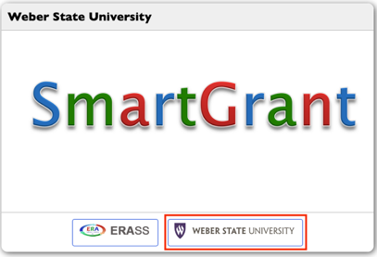
https://wsu.erasoftwaresystems.com
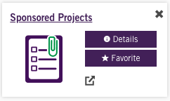

PRE-AWARD
TO ENTER PROPOSAL
- Login using your WSU login credentials
- On top toolbar, go to “Pre-Award” → dropdown “Proposal Functions”
→ “PropXls Proposal” → “New Proposal”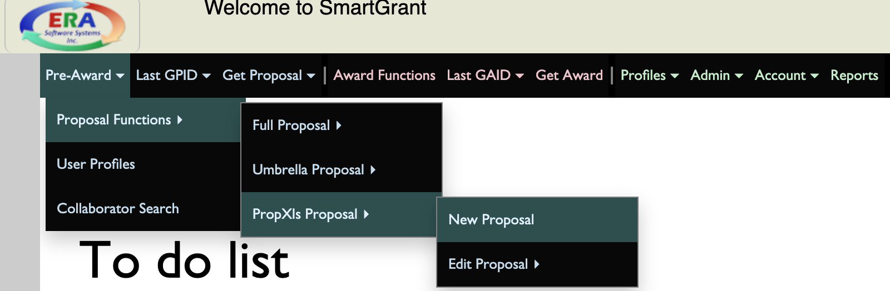
- Enter the proposal title in “Long Title” field
  - Press tab button on keyboard to copy title in “Short Title” field
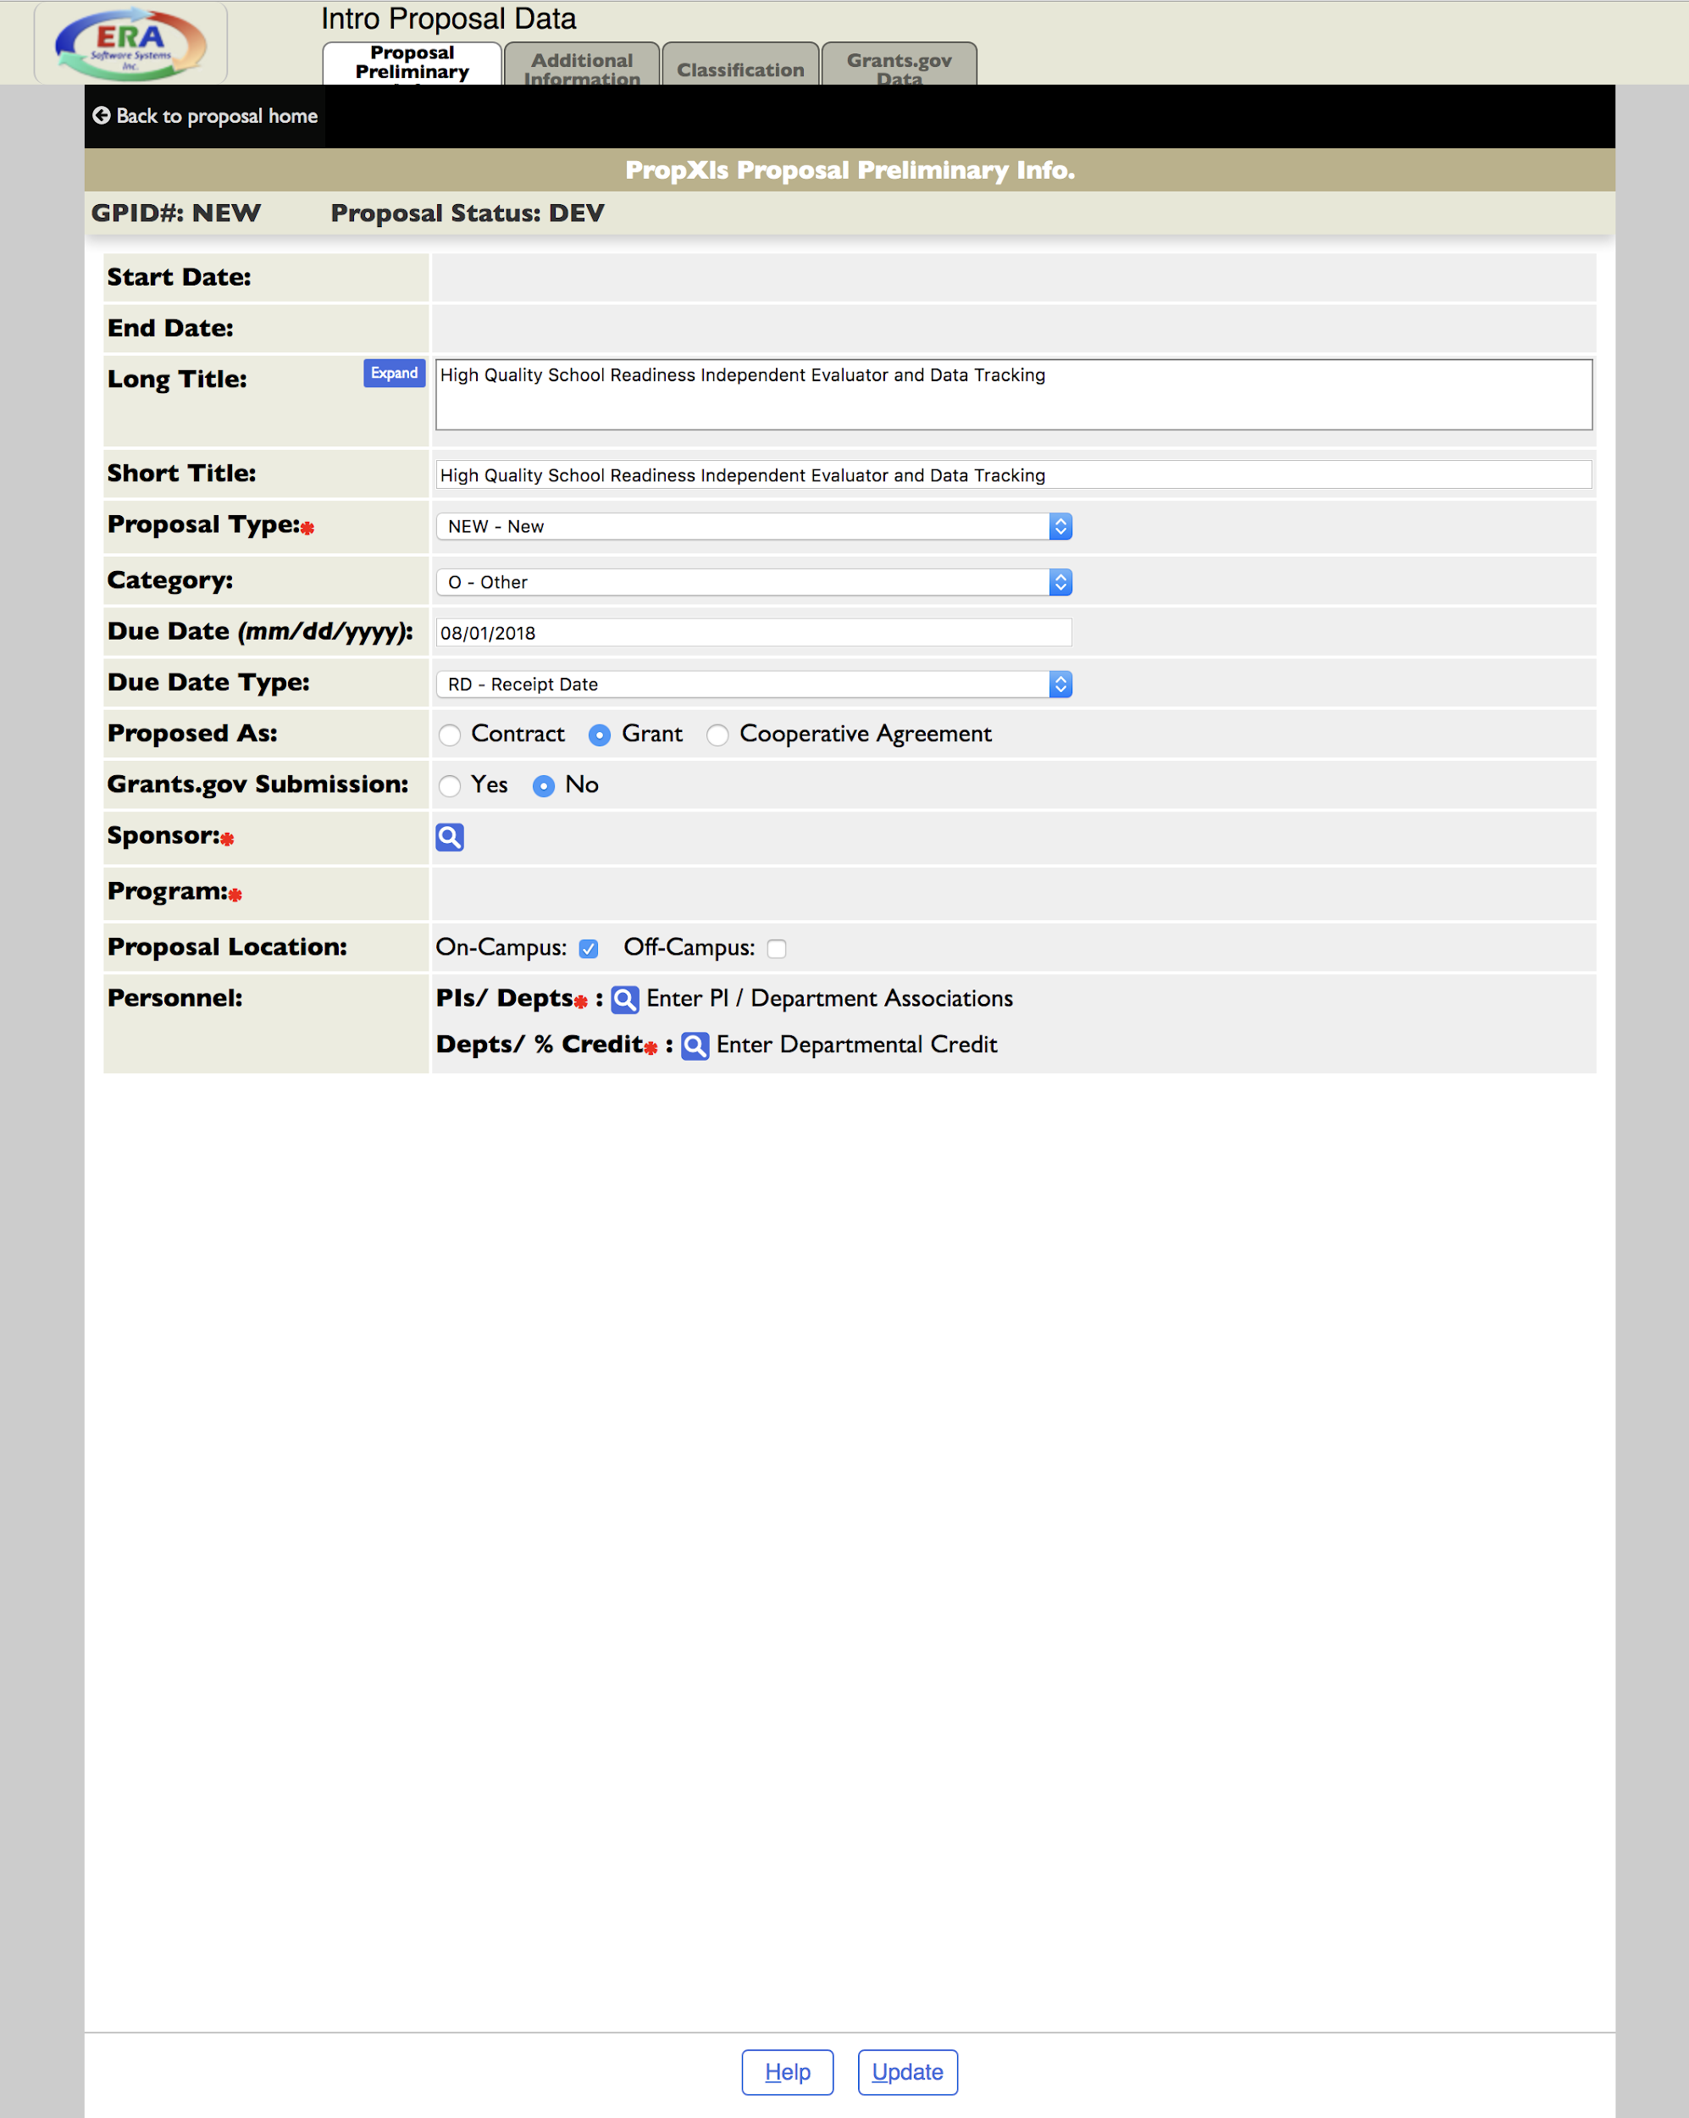
- Click blue magnifying glass icon in “Sponsor” field. In Sponsor Lookup popup window: type sponsor’s name in “Name or ID” → Search → Choose correct name
  - “Type” dropdown → choose correct organization
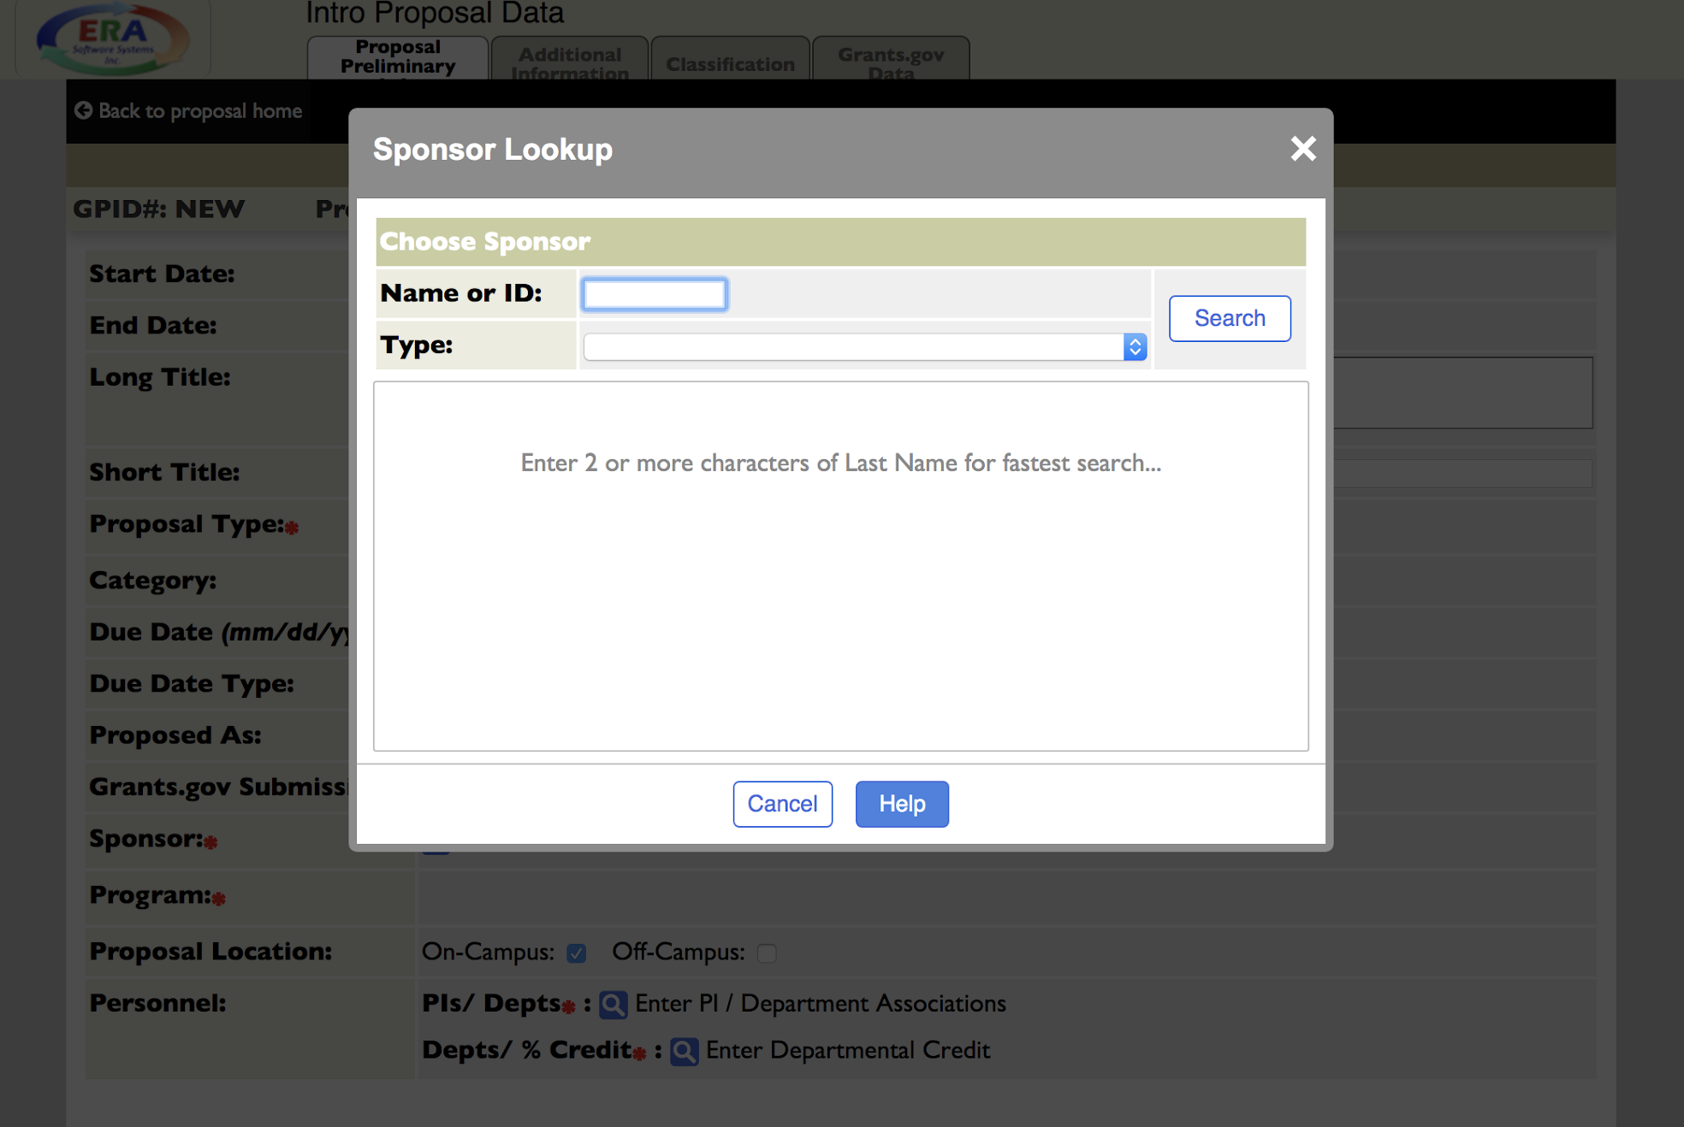

  - In “Sub Program” popup dropdown, choose type:
    - GEN2 General Program (TDC)
    - GEN3 General Program (No Overhead)
    - GEN5 General Program (Salaries & Fringes ONLY)
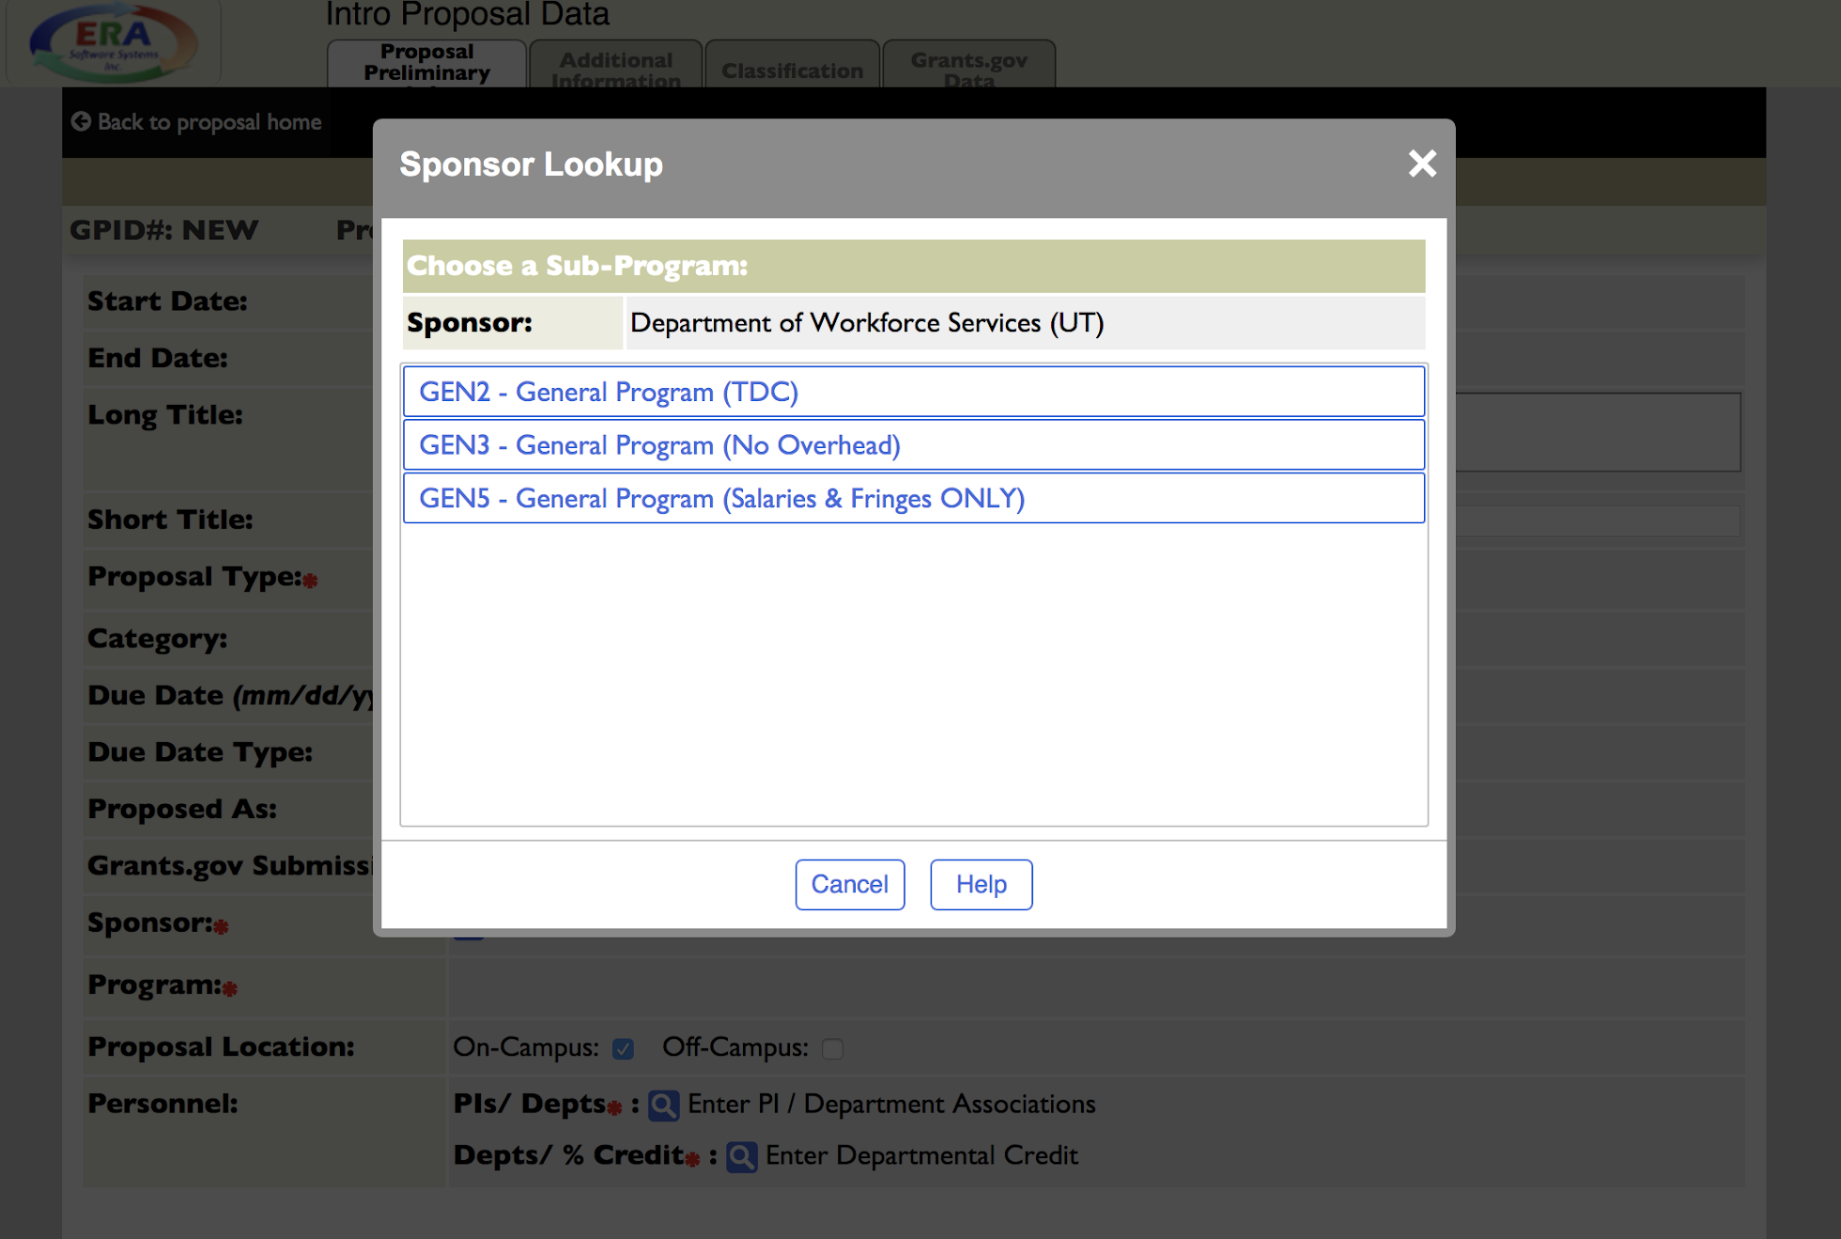
c. UPDATE
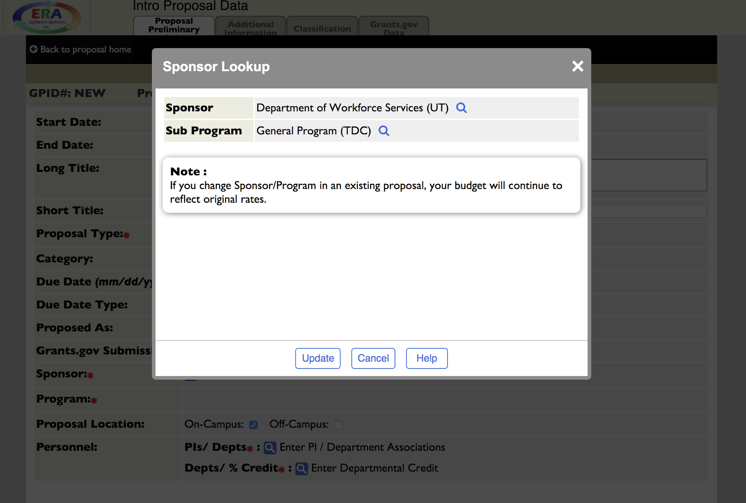

- Choose PI: Enter last name and choose correct corresponding name → click UPDATE
  - Department will auto-populate
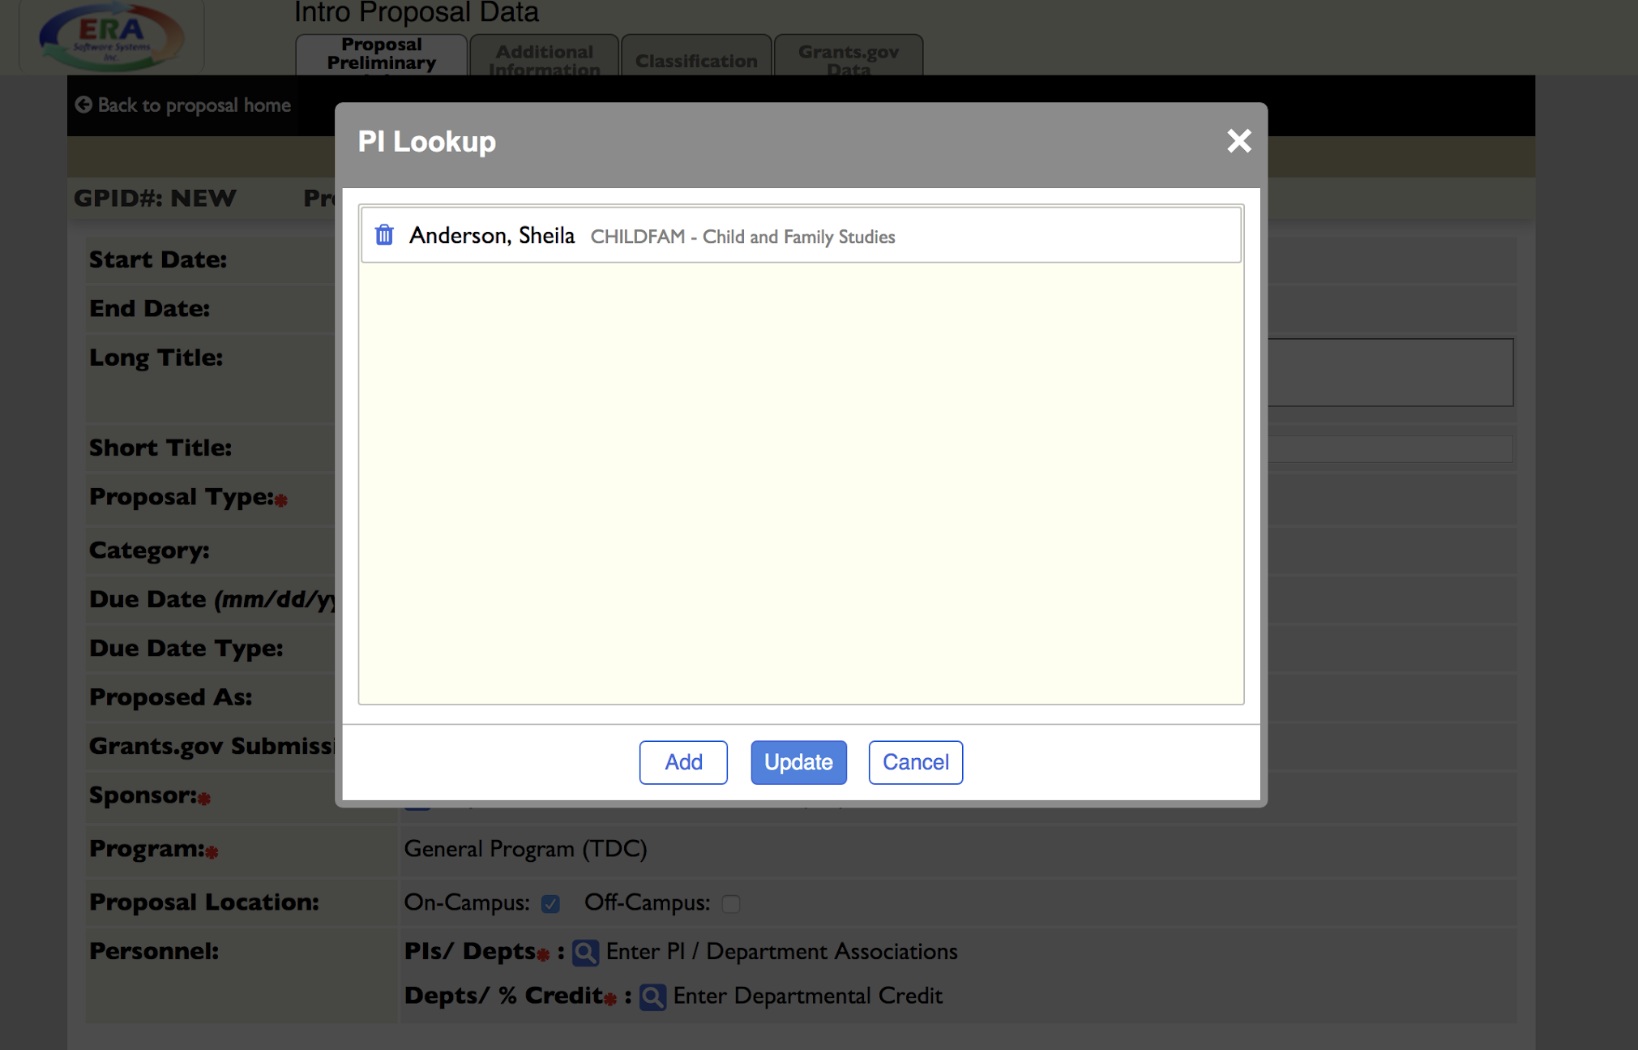

- “Classification” tab on top → choose “General Classification” dropdown and enter information in these fields: Category, NSF SciSurvery, Purpose/Function Classification 1 → UPDATE → “OK” on popup message
- You will now be in Proposal Checklist view
  - “Proposal Information” dropdown → Internal Processing Form
  - “General” tab: PI will fill out
  - “Additional Resources” tab: PI will fill out
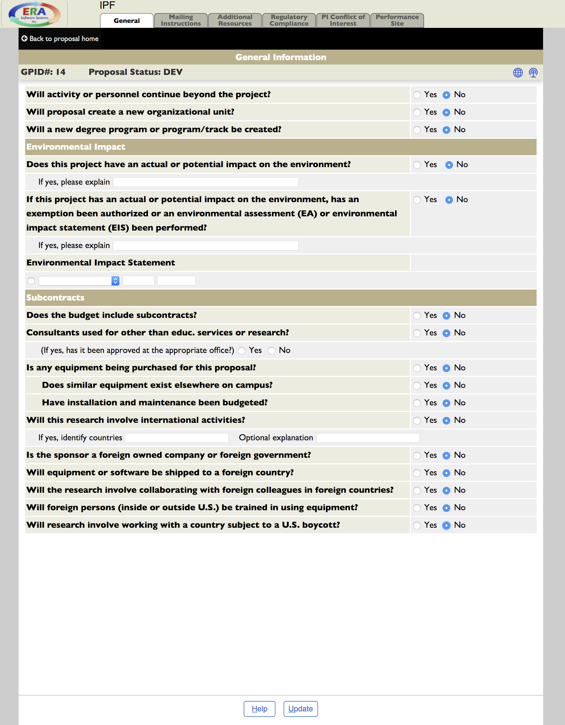

  - UPDATE → OK
- In top left, click “Back to Proposal Home”
- “Budget Functions” tab → “Budget Prelim Info”
  - Enter Project State Date
  - Enter Project End Date
  - Budget-Period-Dates: If grant is over a year, choose “Manuel Entry”
  - You will now be in Budget Prelim Info view
    - Choose “F & A Rate Justification”
      - Enter “Comments” will specific percentage if the indirect cost rate is reduced
    - Change F & A Rates in FY-1 and FY-2 to reflect TDC → UPDATE
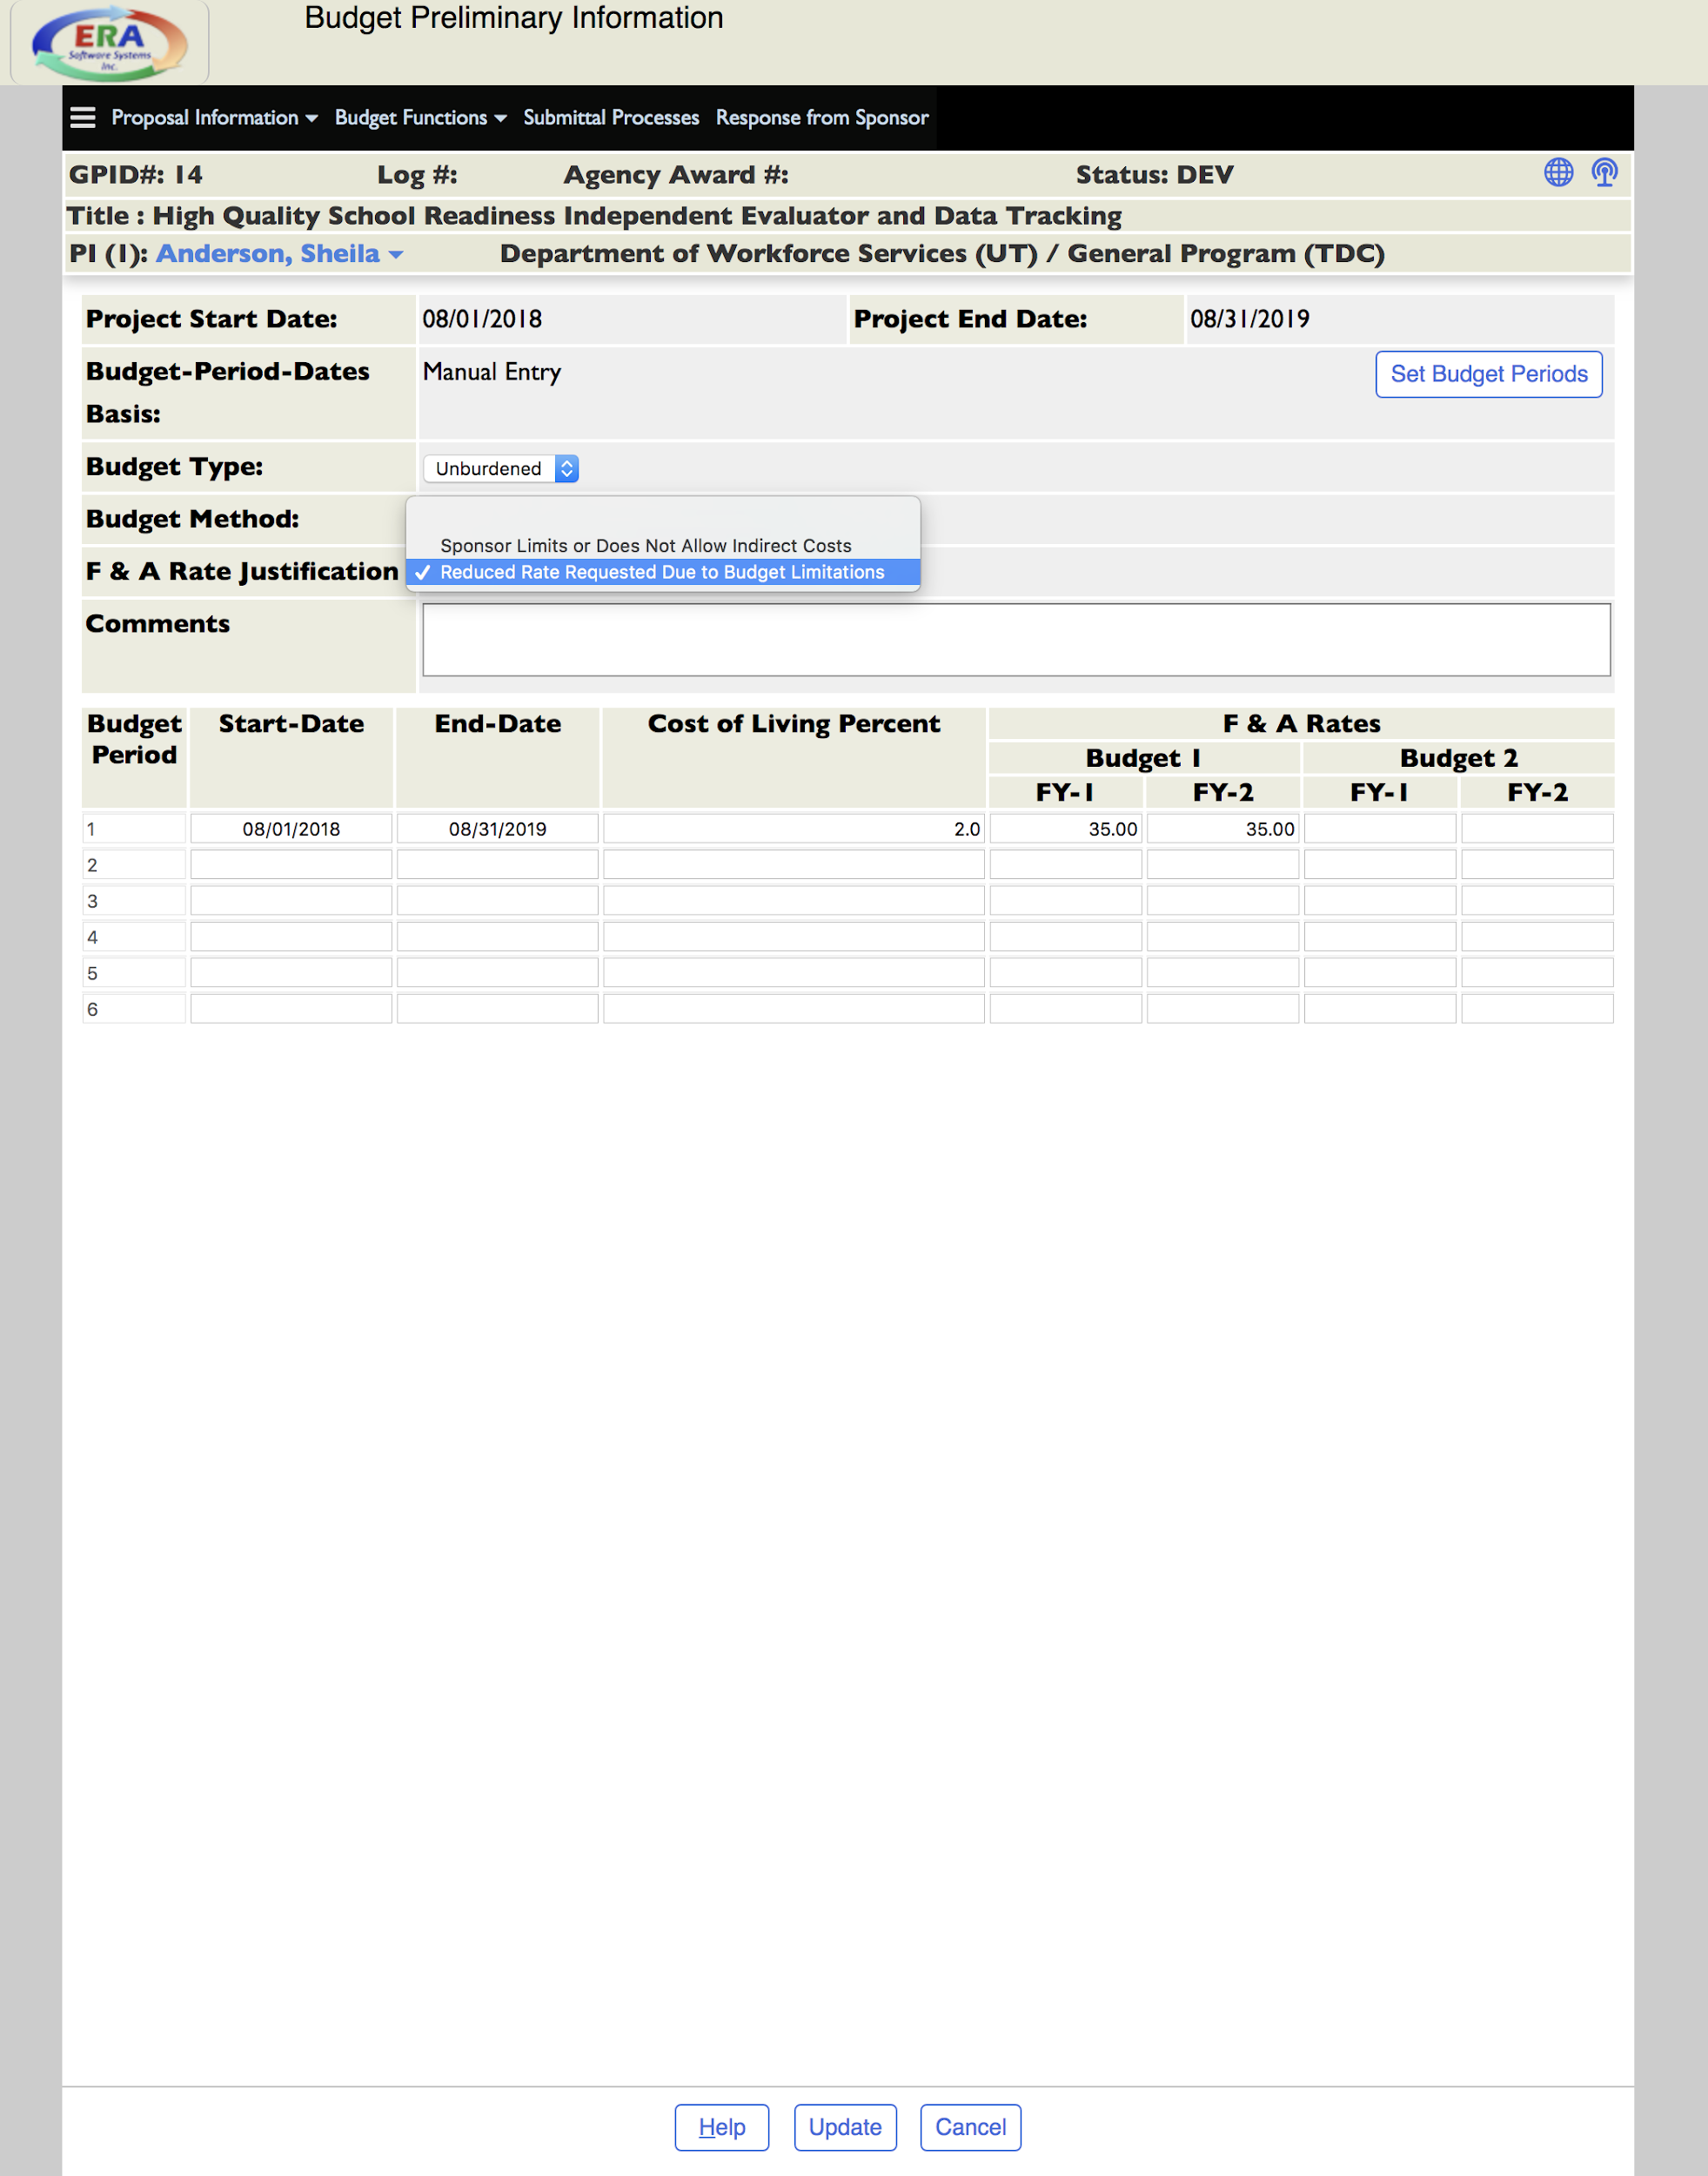
- UPDATE
- “Budget Functions” dropdown → PropXls budget
    - Scroll “Budget” table → click on number in field to enter line items → “Insert Line”
    - To enter wages, choose “PI,” “Senior,” and/or “Other Personnel”
      - Enter information → UPDATE
      - To enter buy-out, enter actual percentage of salary in “Regular” pay
    - To enter non-wages, click on number in field under “Non-Personnel”
      - Enter information → Add Description, if needed → Enter Amount” → UPDATE
      - “Insert Line” to add as many line items as needed → UPDATE
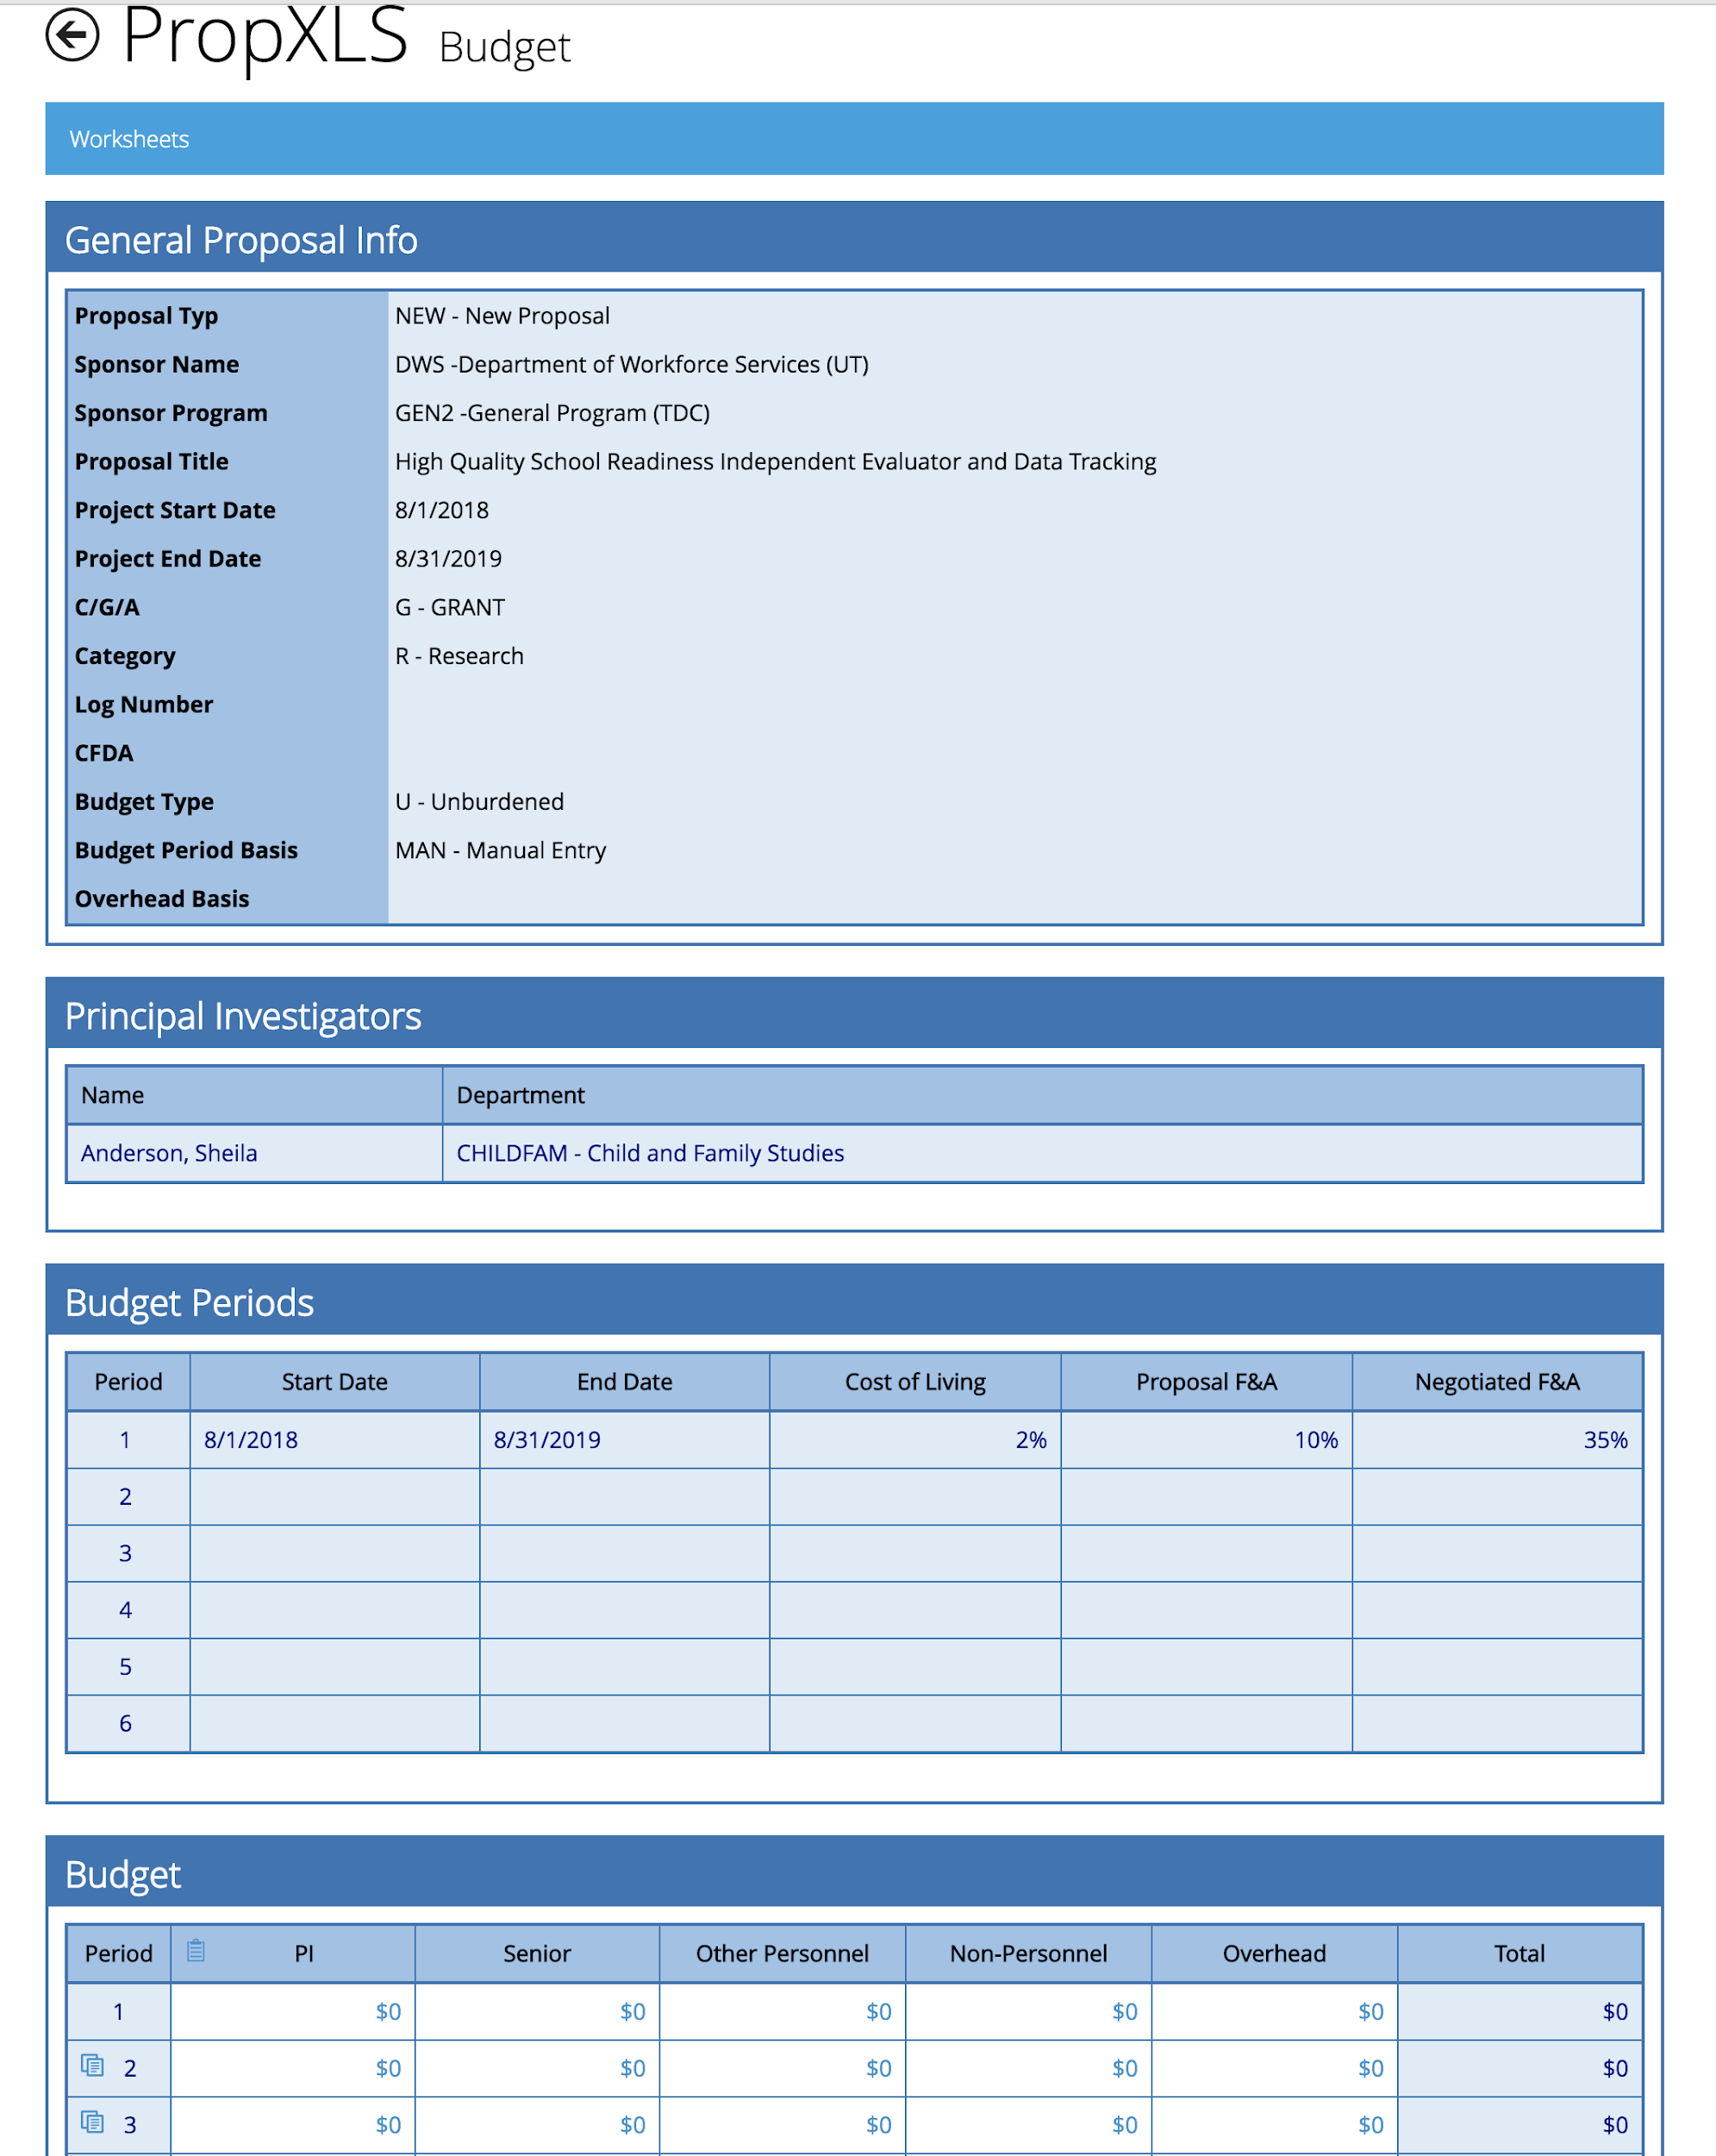
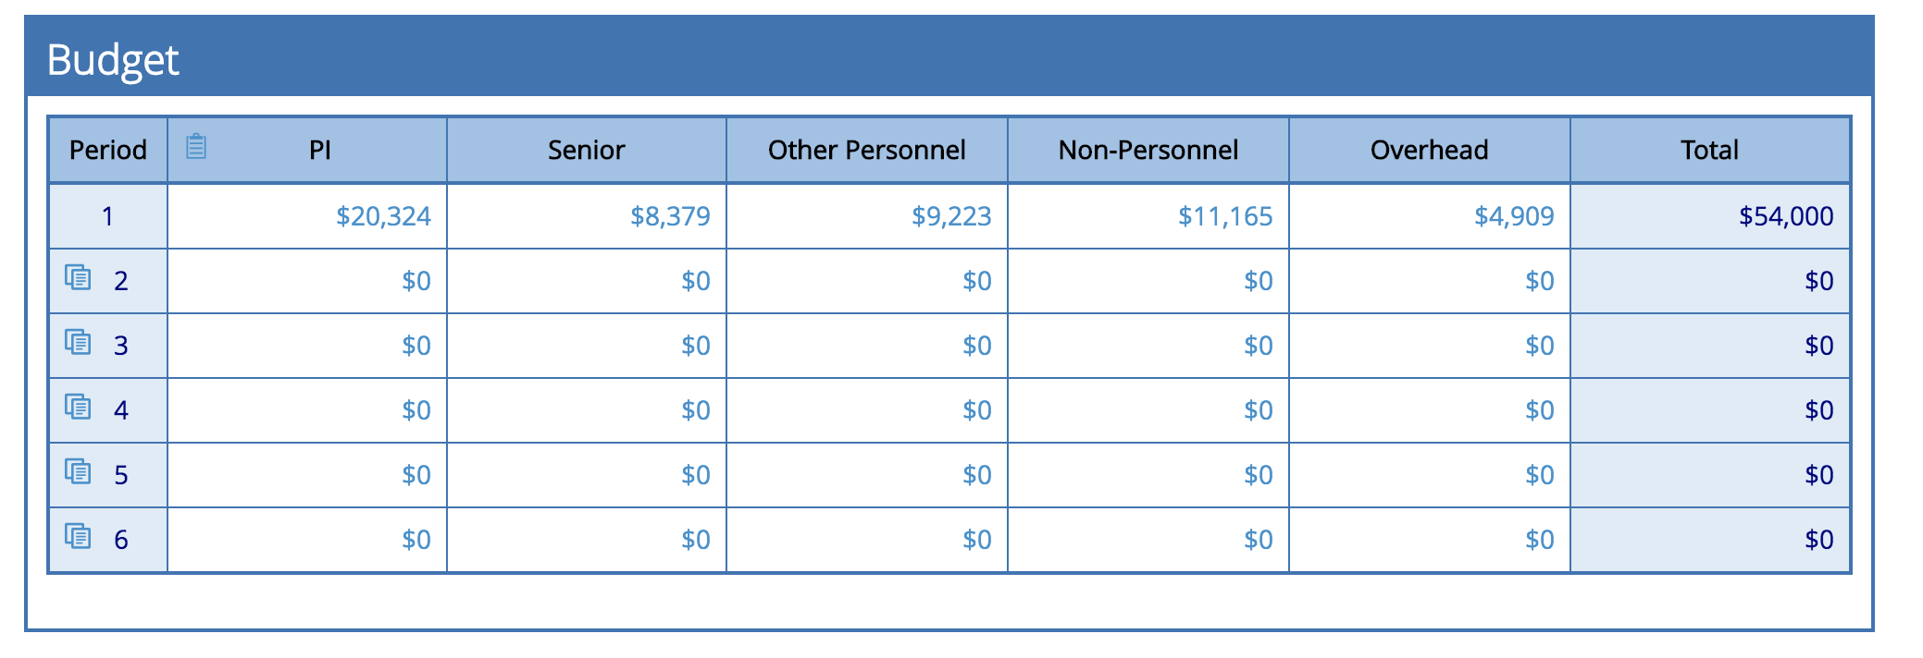
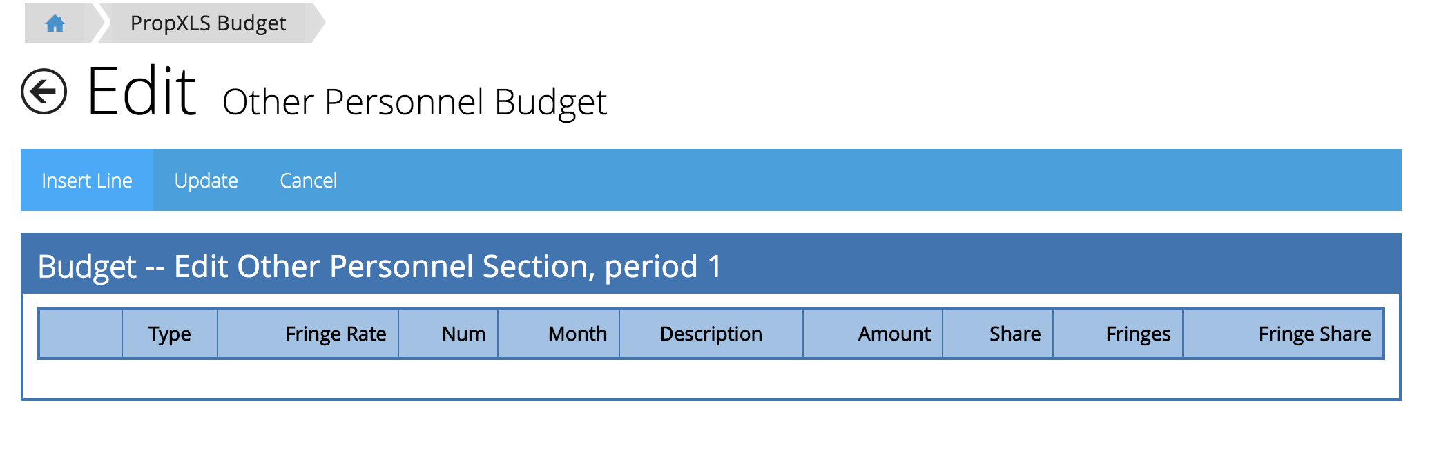
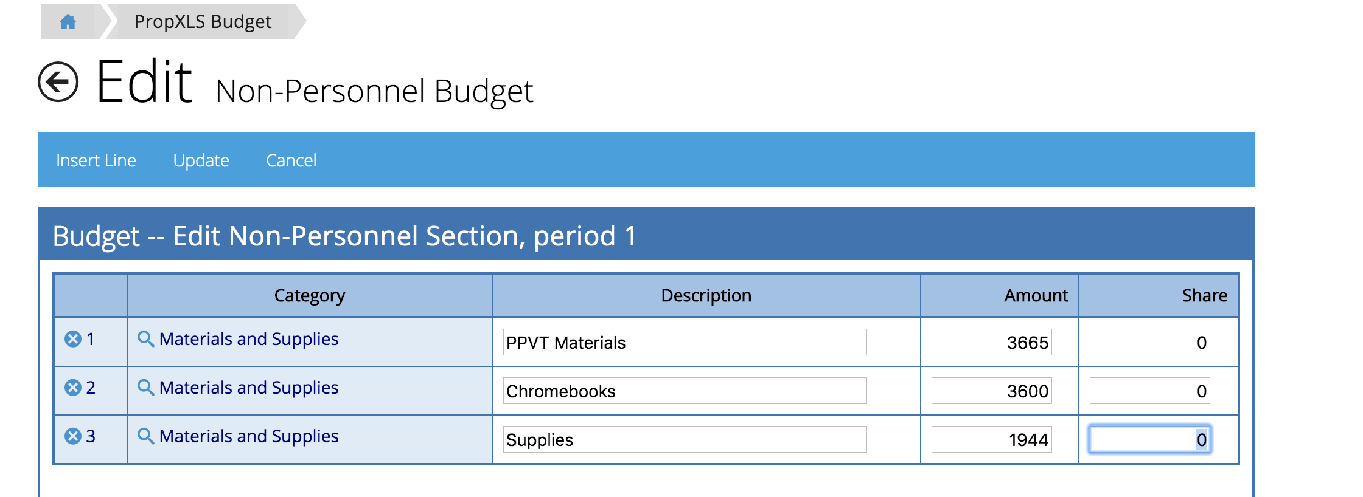

    - To enter overhead: “Overhead on Directs” → Enter description, if needed.
  - “Worksheets” on top left: this will show your budget Proposal Spreadsheet → Exit → Back arrow in program to left of “Edit”

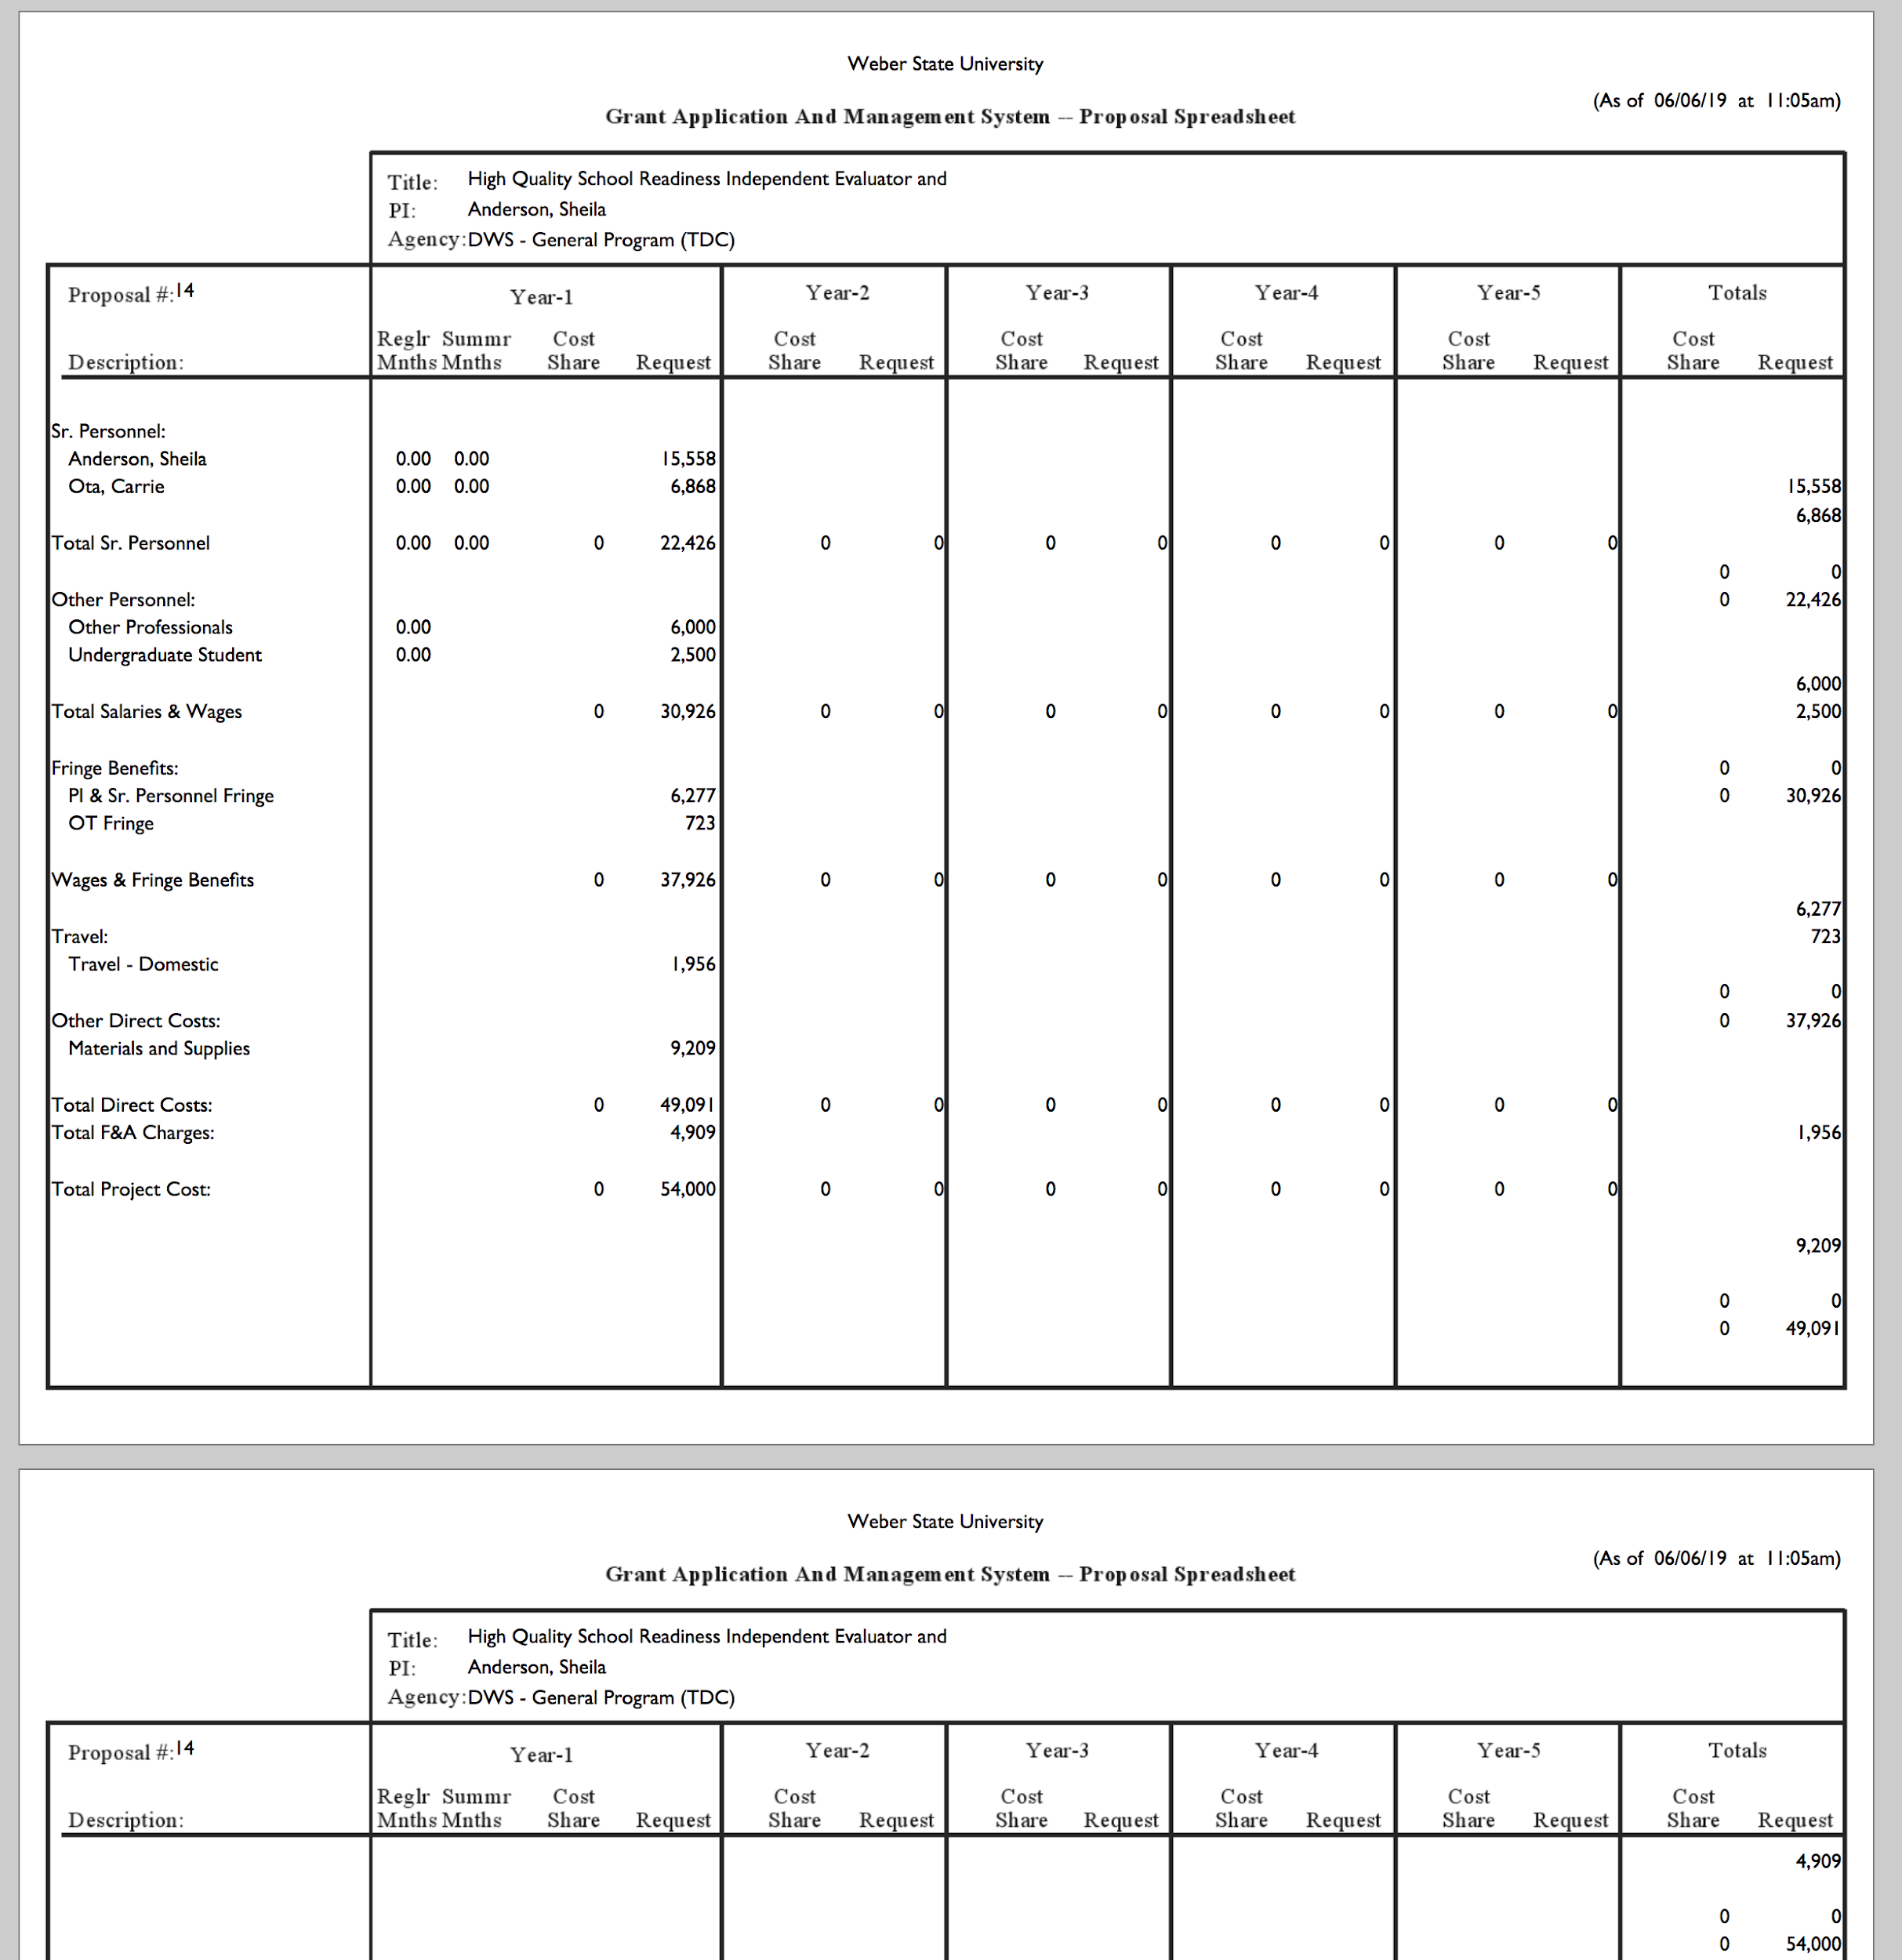

- Submittal Processes → Print Forms → OK: brings you to Sponsors Forms page → Back to Proposal Home
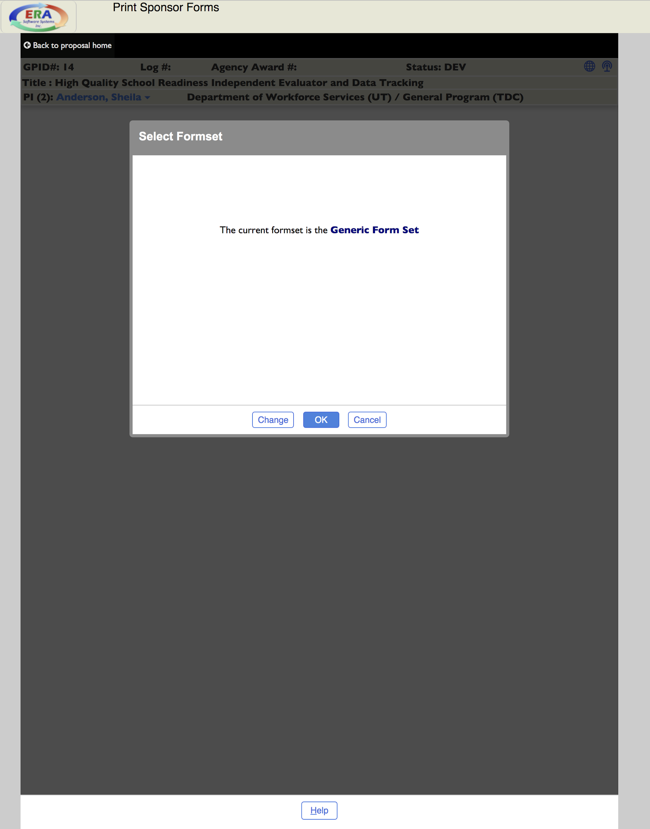
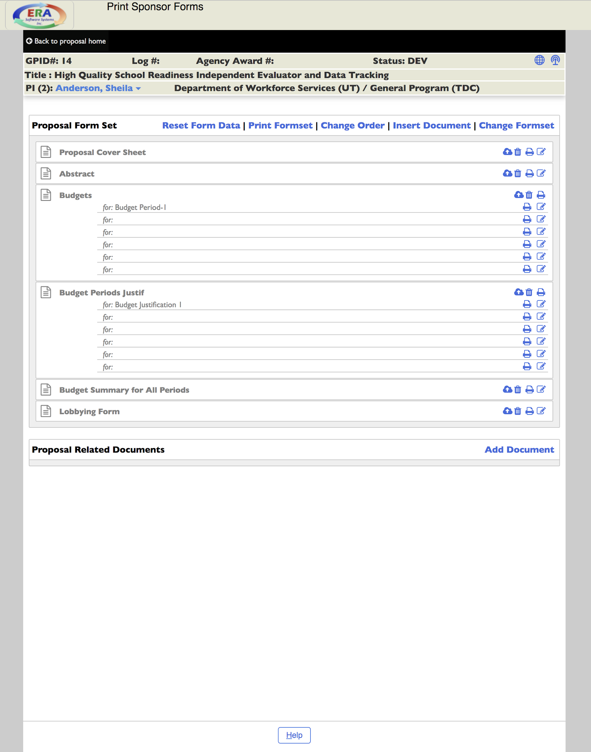
- Submittal Process → Online Routing → Start online routing: will show the routing status as “Completed”
- Submission to Sponsor → Select “Authorized Rep” with your name → Update → OK
  - Status: SUBM
- To award, go to tab “Response from Sponsor” → Select from “Sponsor Reply” dropdown
  - Select Form Number of Accounts to be Used
  - Under Current Sponsor Obligation, enter “Sponsor ID” (this is the grant number for old projects) → UPDATE
- In Award Profile Review, the award status will show FUNDED → Back to proposal home → Back to Main menu

POST-AWARD
TO MONITOR BUDGETS, MANAGE COMMUNICATIONS, AND ROUTE TO ACCOUNTING

- Top menu bar “Award Functions” → Update Awards → List Awards → List
  - Find current working award to complete post-award
- On worksheet tabs, “Internal Contact” → Close, External Contacts → Close, Deliverables → Close, Terms & Conditions → UPDATE → Close, Compliance and Disclosures → Cancel, Classification → Cancel
- Top menu bar, “NOA/MOA” → Generate NOA/MOA → close popup window
- Top menu bar “Accounting” → Add New Index
  - Account Number: enter Index Number
  - Account Type: Master-ACCT
  - Department: select department, not college
  - F & A Rates: enter Actual, Allowed, Negotiated: always 35%, Use Rate
  - F&A Basis: select from dropdown
  - Budget Method: ABR Rule 1→ UPDATE
- Top menu bar “Accounting” → Budget Changes
  - Budget Changes → Initial Budget
  - Pull Proposal → Request Approval → OK
  - Revision Approval → Signature → Drop down menu: Approve → UPDATE
  - At this point, Accounting will approve budget. Once approved: POST → OK
  - To ensure the award posted: Continue → Back to Award → History Log
