PI Setup
Add a Principal Investigator (PI) to the SmartGrant database

- Profiles Personnel Add a New Personnel
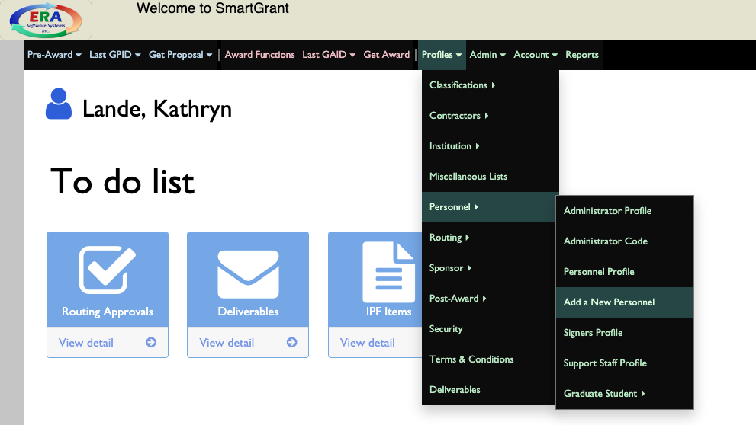
- With ID prompt, input P.I.’s W# Select
  - To lookup W#: go to eWeber Portal Administrative Access app click on Sponsored Projects under “Select Function” dropdown, select User Maintenance Search via Last Name copy W#
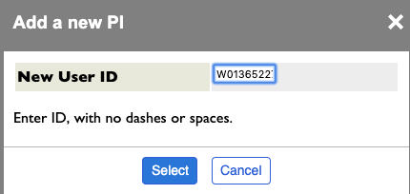

- In “Personnel Demographic Information” screen view under “Personnel Basic Info” tab, input the following fields:
  - First Name
  - Last Name
  - Institution Affiliation Weber State University
- In “Personnel Demographic Information” screen view under “Personnel Dept & Pay” tab click Add input the following fields:
  - Department
  - E-mail
  - Appointment Type
  - Statue
  - Fringe Type
  - FTE%: this field determines the department commitment time and is usually 100% or 50%
    - To confirm Appointment and Fringe Types, go to eWeber Portal Reporting Argos Web Viewer Budget – Campus Access Benefit Analysis by Individual enter today’s date and W# click Benefit Analysis by Individual Report Run
- Click Update OK

To setup a PI login access:

- Profiles Security
- Enter in “Name or ID” field the PI’s name in all caps first & last: FIRSTLAST Add new
- In the “Security Profile” view under “General Profile Setup” tab, enter the following fields:
  - Expiration Date: this can be a date in the future, like 1/1/2035
  - Name: First Last
  - Password: enter whatever, like OSP123
  - Department
  - E-Mail
  - Only Institution
  - PostAward Access Level: PI.OPTS – Principal Investigators
- Update OK
- “Investigators” tab Add
  - Last Name: enter last name Search Select correct PI
  - Access: U – Update access
  - Update
- “Routing Access Info” tab Add
  - Levels: LP – PI
  - Level Identifier: FIRSTNAMELASTNAME
  - Update

