GRANTS.GOV APPLICATION
APPLY FOR FEDERAL FUNDING AND ACCESS GRANTS.GOV THROUGH SMARTGRANT

- Once signed in to SmartGrant, on top menu select “Submittal Process”
then “Print Forms” from dropdown
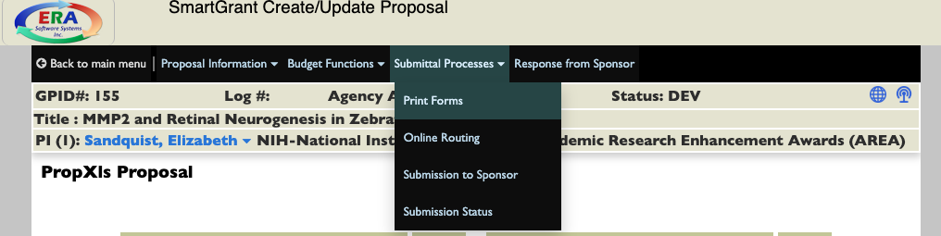

- This will bring you to “Grants.gov” page
Select “Fast Grants” on top menu
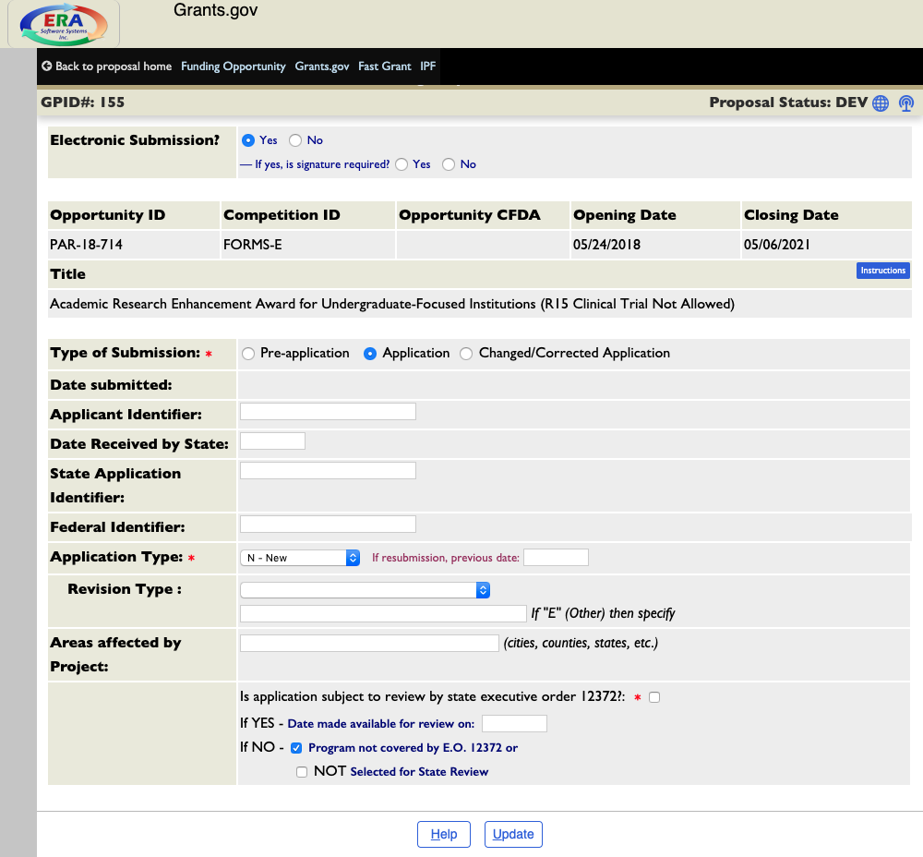

- An alternate window will open. Forms for your specific grant are tabbed on the left side of the page:
