ACKNOWLEDGMENT AND POLICY FORMS
Send PIs forms for electronic signatures via SmartGrant Communication log

SENDING FORMS
- In SmartGrant, select the award with the PI who needs to sign forms
- On the top menu, select “Communications”

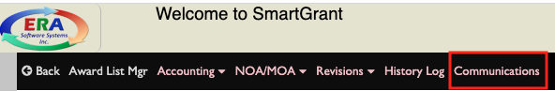
- A pop-up box will open, select “Add”
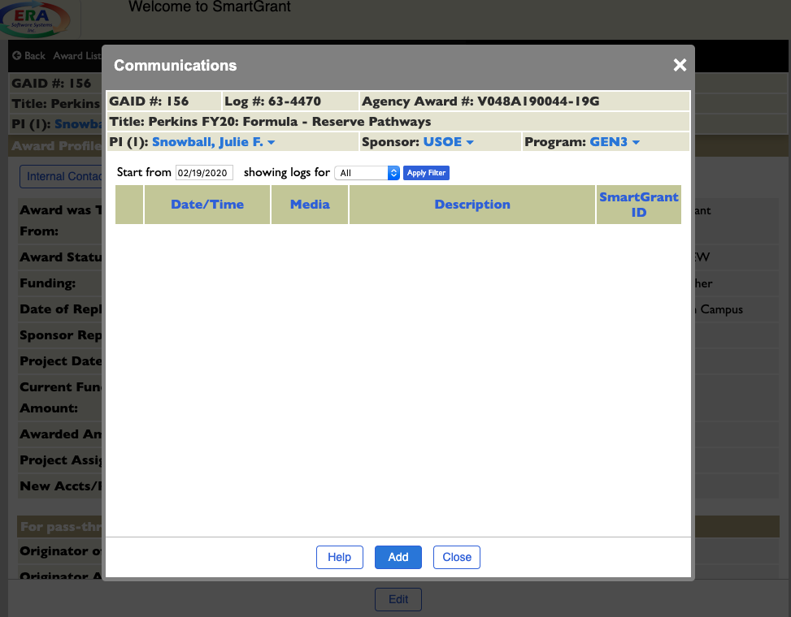

- In the communication pop-up, complete the following:
  - Subject: suggested “Signature Required: OSP Forms”
  - Medium: select “Email”
  - Type: “Compliance”
  - Email Source: leave blank
  - Public/Private: “Public”
  - Send Email: select the box, then click on the person icon
    - You will be prompted to choose from auto-populated lists based on the PIs department chair, dean, or co-PIs
    - Select recipients to send email to, including CC and BCC options
  - Attachments: click on the paperclip icon to choose attachments to send
  - Communication Text: type personalized note. Important — include instructions for email recipients to respond directly to the original email. This ensures communications are logged within SmartGrant, without having to upload emails, notes or other files.
    - Suggested text: To submit, reply directly to this email with completed forms attached. Or provide your written consent with “Approved” in your email response. COPY & PASTE THIS TO THE SUBJECT LINE: [GAID:GAID#]
  - Update
