COMMUNICATION LOG
Track all communications and house documents in SmartGrant

SENDING EMAILS
- In SmartGrant, select relevant award
- On the top menu, select “Communications”

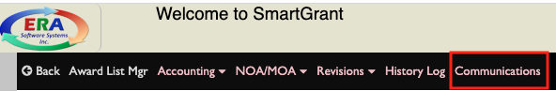
- A pop-up box will open, select “Add”
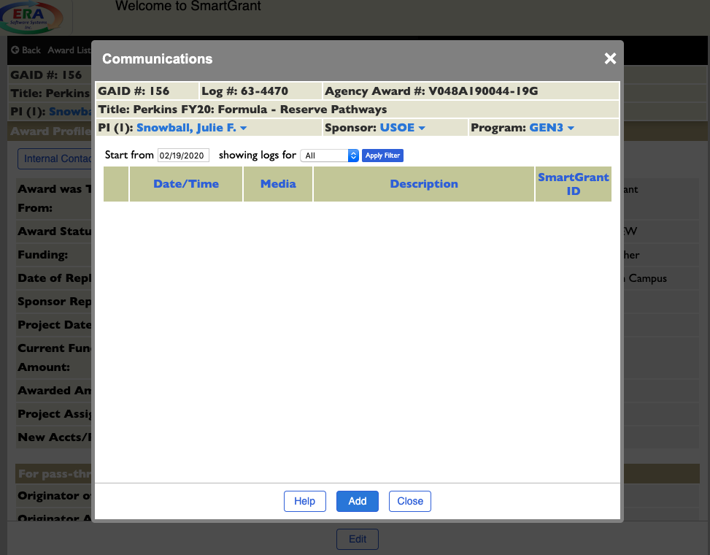

- In the communication pop-up, complete the following:
  - Subject:
  - Medium: select “Email”
  - Type:
  - Email Source: leave blank
  - Public/Private: “Public”
  - Send Email: select the box, then click on the person icon
    - You will be prompted to choose from auto-populated lists based on the PIs department chair, dean, or co-PIs
    - Select recipients to send email to, including CC and BCC options
  - Attachments: click on the paperclip icon to choose attachments to send
  - Communication Text: type personalized note. Important — include instructions for email recipients to respond directly to the original email. This ensures communications are logged within SmartGrant, without having to upload emails, notes or other files.
    - Suggested text: To submit, reply directly to this email with completed forms attached.
  - Update
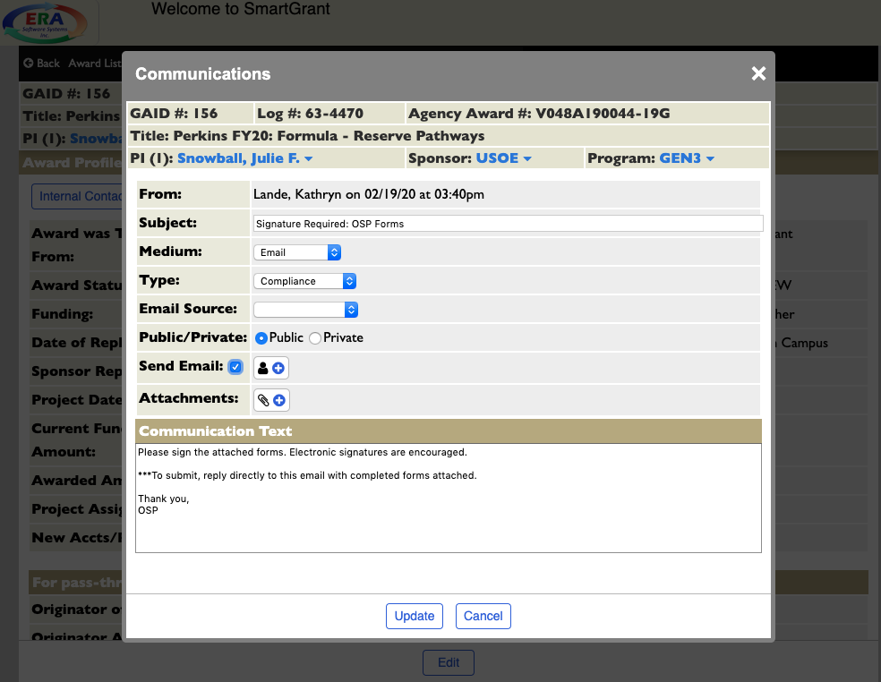

ADDING NOTES
- In SmartGrant, select relevant award
- On the top menu, select “Communications”

- A pop-up box will open, select “Add”

- In the communication pop-up, complete the following:
  - Subject:
  - Medium: select “Note to File”
  - Type:
  - Email Source: leave blank
  - Public/Private: “Public”
  - Send Email: leave blank
  - Attachments: click on the paperclip icon to choose attachments to send
  - Communication Text: type personalized note.
- Update

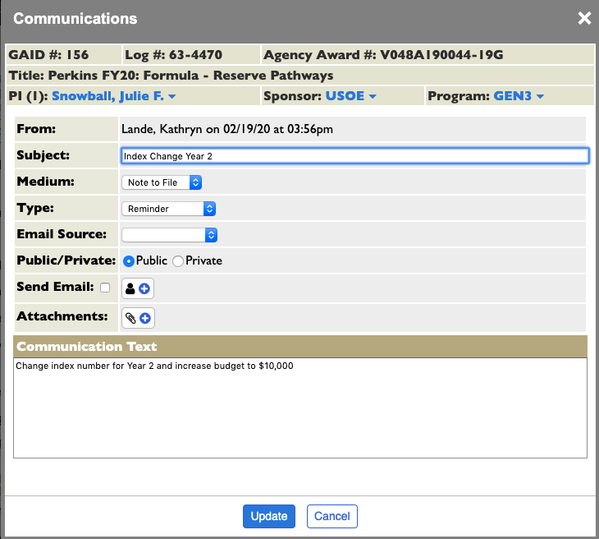

VIEWING COMMUNICATIONS
- In SmartGrant, select relevant award
- On the top menu, select “Communications”

- Select “Edit” icon on left of communication to open, view attachments, print, or delete
