SOP: CLOSE AWARDS
Close or inactivate an award. Note: closed awards in SmartGrant will remain active in Banner.

- View award profile in Post Award
- Click Edit on bottom
- In “Award Close Out” field, check “Close” status and set date

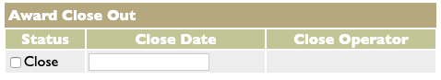

-OR-
- View award profile in Post Award
- Click Edit on bottom
- In “Award Status” field, choose Inactive
