SOP: BUDGET CHANGES
Re-assigned sub codes or increase/decrease previously approved budget in SmartGrant post-award

- Find the award to be modified in the post-award side of SmartGrant:
  - Award Functions Update Awards List Awards
  - Click “List” next to the Funded Research to bring up the full listing
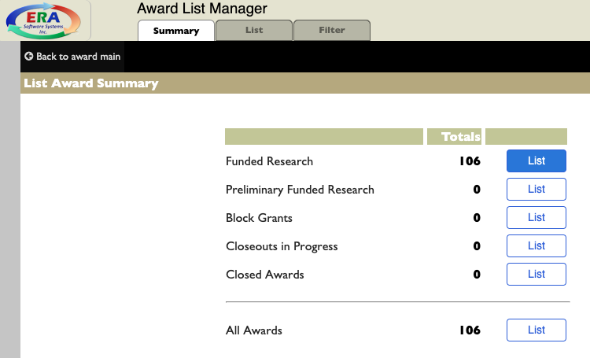

  - To access specifics on an award, click on the blue ID number on the left
- In the Award Profile Review view in the top menu, choose “Accounting” then “Budget Changes”
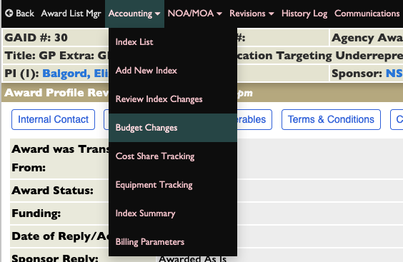

- In the Account Codes/Cost Type view in the top menu, choose “Budget Changes” then choose if you need to “Re-Allocate” (to change sub codes), “Increase” or “Decrease”
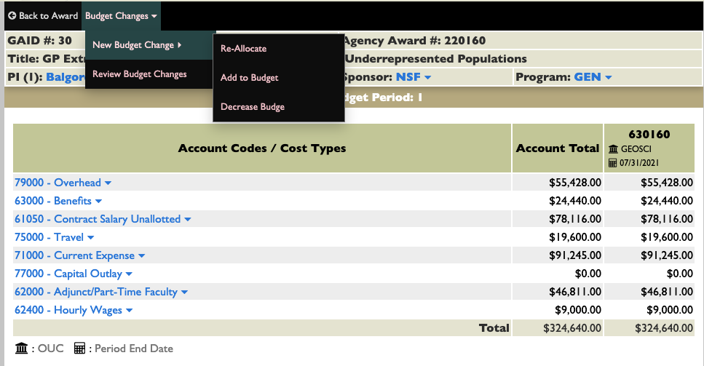

To Re-Allocate:
- In “Change Justification” field, type reason for change. i.e. “change code” or “add indirect costs”
- Choose from dropdown in Justification Code/Reason Continue
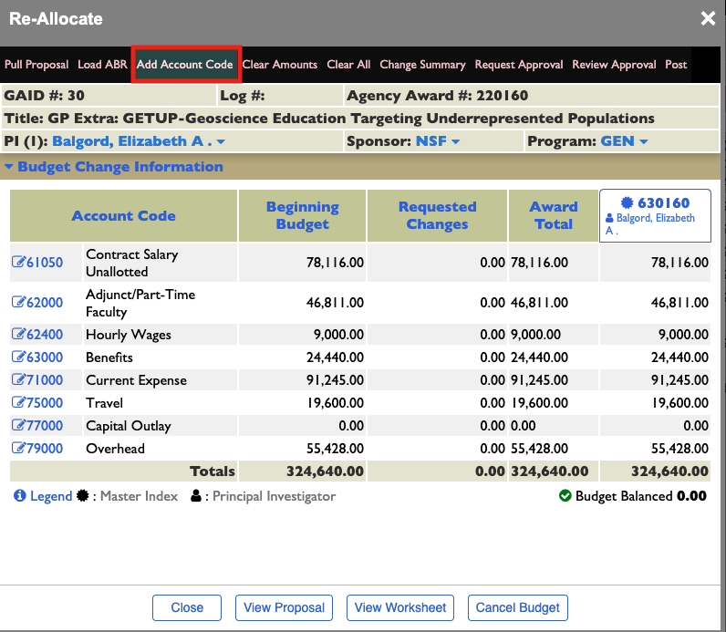

- Type correct account code in field Search
  - This pulls up the account code with description. Check if correct Add Selected
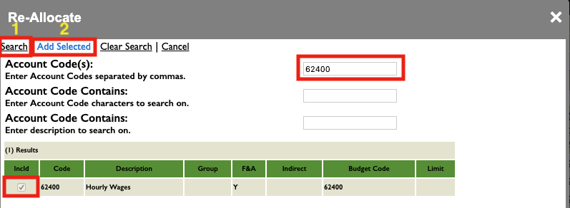

- Click on budget code to add or decrease monies from and entered in “Requested Changes”
- Budget should be balanced Update Done
