ACCOUNTING REVIEW FOR APPROVAL
Communication and process for accounting’s review of budget and index number requests

REVIEWING PENDING REQUESTS
- Login to SmartGrant via eWeber app:
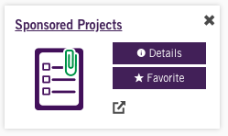
- Click the “Weber State University” icon on the bottom right and sign in using your WSU login credentials—Duo approval will be required:
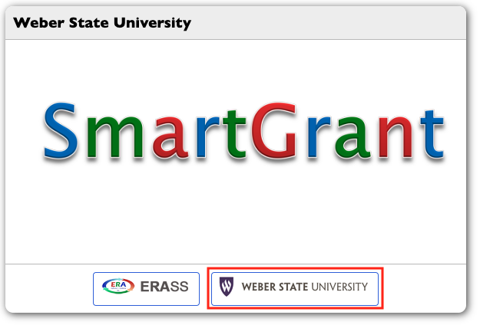
- After a signing in, the SmartGrant home screen will display your “To do list”— click on “View detail”:
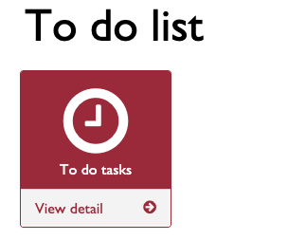

- All pending tasks will be displayed. To access an individual task, click on the blue pencil icon to the left of the GAID number:
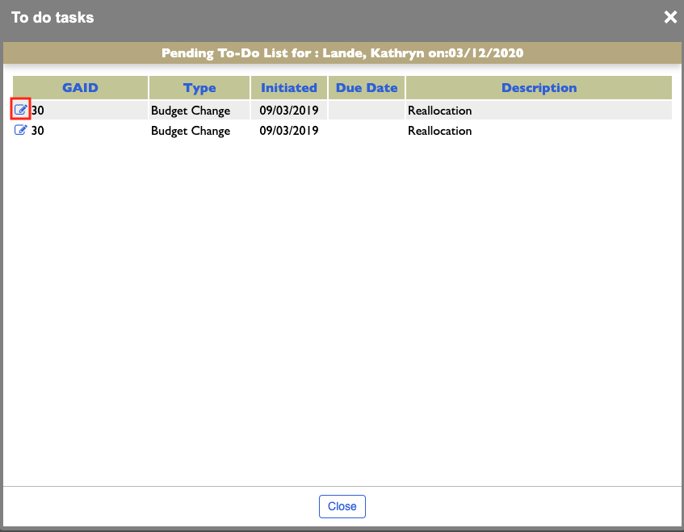
- The budget will be displayed, including all index numbers and Account codes. Select “Revision Approval” on the top, near right menu in red text:
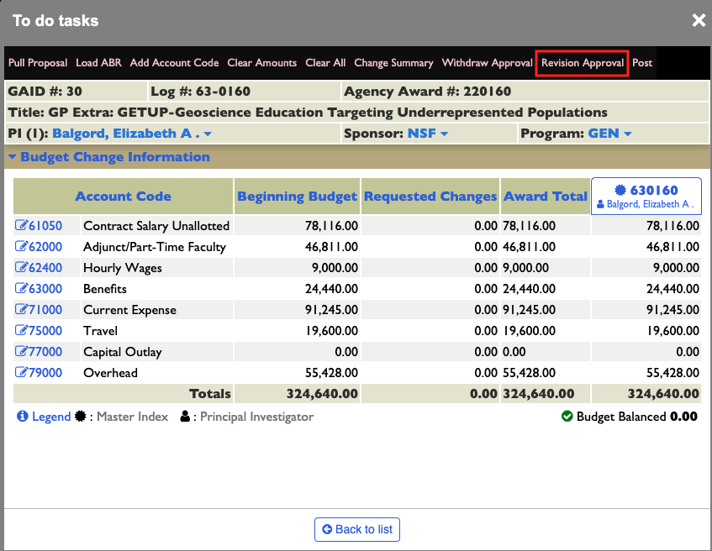
- To view Account Code breakdowns, click on the blue pencil icon on the left of the selected Account Code. This screen will display:
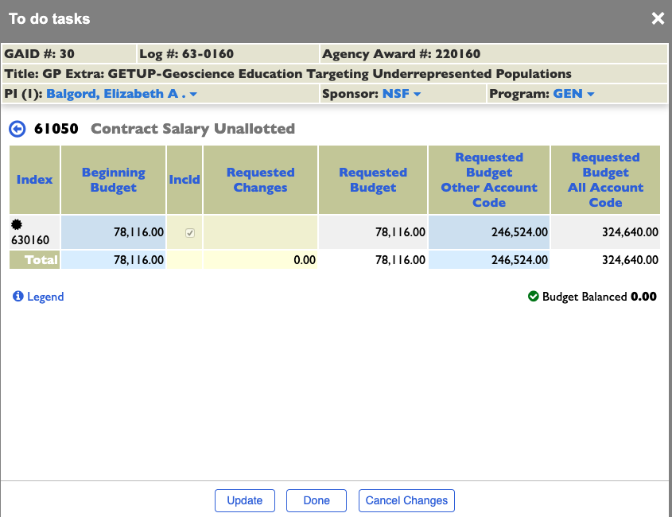
- To view an individual index number breakdown, click on the selected index number column:
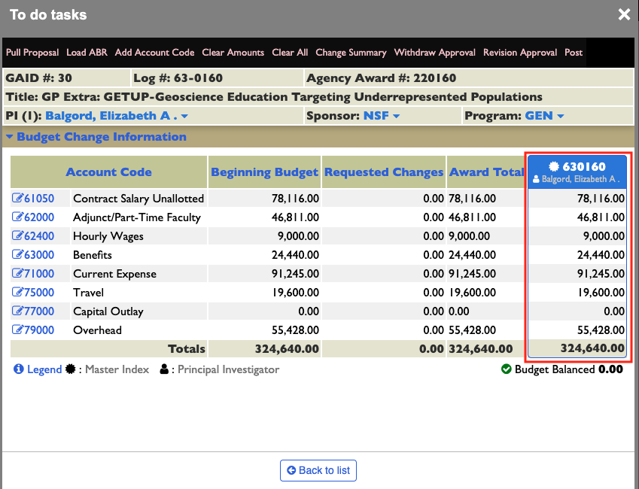

- This is what the index number display looks like:
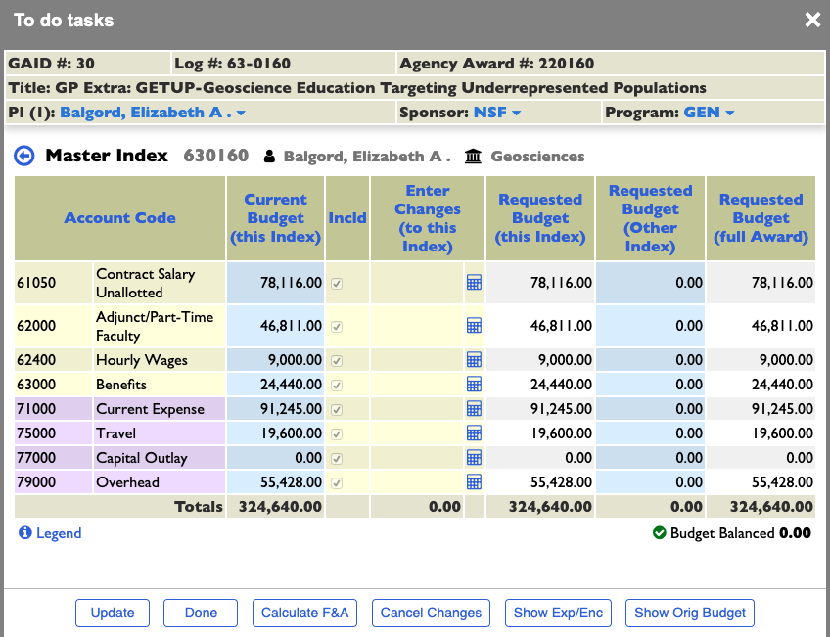

- To approve or reject an initial budget or budget revision, click “Signature”:

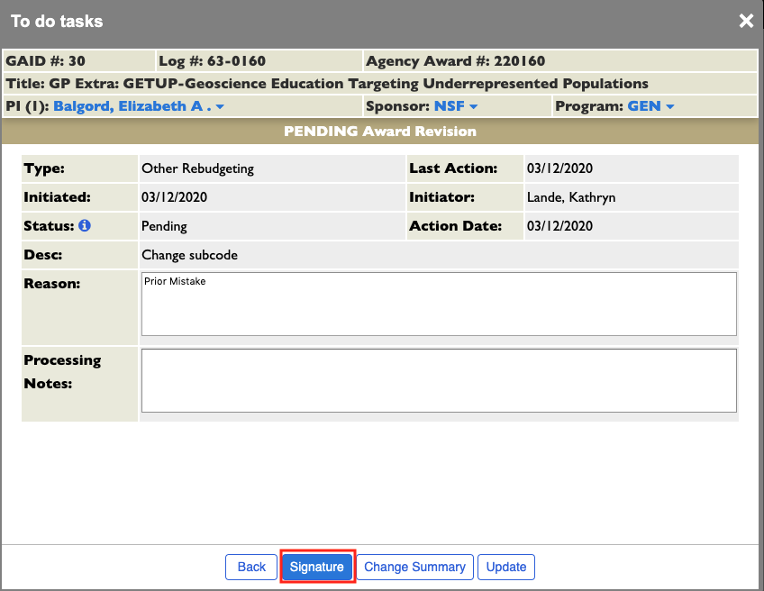

- Under the “CG Contracts & Grants” section, select from the left dropdown to Approve or Reject and include necessary notes in the “Comments:” section:
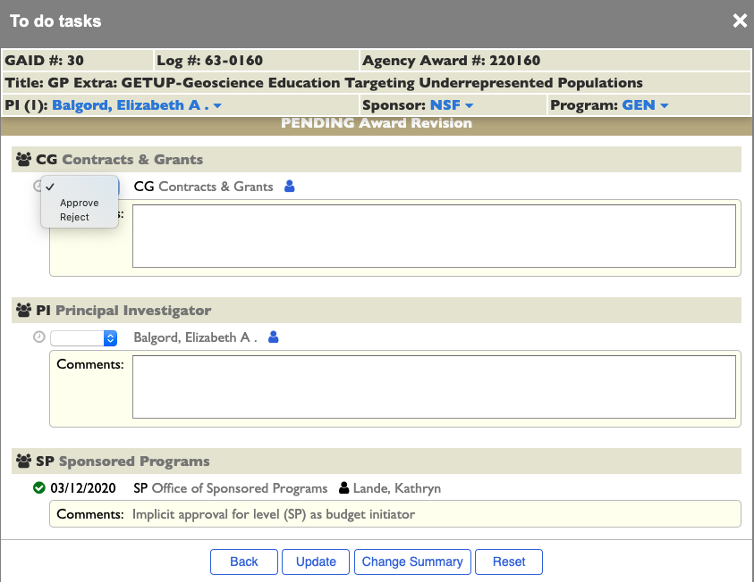
- Select “Update”

SENDING EMAILS
- In SmartGrant, select relevant award
- On the top menu, select “Communications”

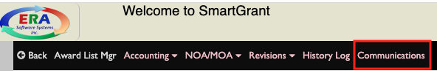
- A pop-up box will open, select “Add”
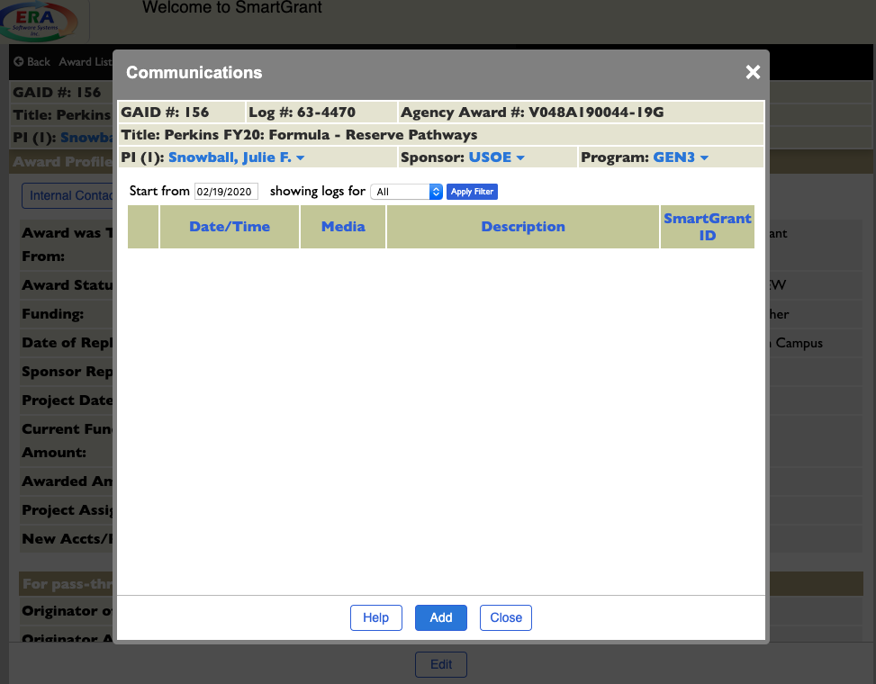

- In the communication pop-up, complete the following:
  - Subject:
  - Medium: select “Email”
  - Type:
  - Email Source: leave blank
  - Public/Private: “Public”
  - Send Email: select the box, then click on the person icon
    - You will be prompted to choose from auto-populated lists based on the PIs department chair, dean, or co-PIs
    - Select recipients to send email to, including CC and BCC options
  - Attachments: click on the paperclip icon to choose attachments to send
  - Communication Text: type personalized note. Important — include instructions for email recipients to respond directly to the original email. This ensures communications are logged within SmartGrant, without having to upload emails, notes or other files.
    - Suggested text: To submit, reply directly to this email with completed forms attached. Subject line MUST include [GAID156] before all other text.
  - Update
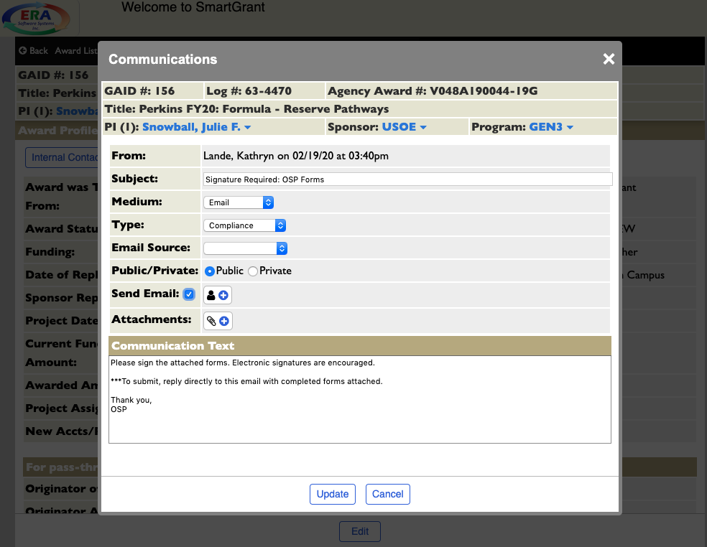

ADDING NOTES
- In SmartGrant, select relevant award
- On the top menu, select “Communications”

- A pop-up box will open, select “Add”

- In the communication pop-up, complete the following:
  - Subject:
  - Medium: select “Note to File”
  - Type:
  - Email Source: leave blank
  - Public/Private: “Public”
  - Send Email: leave blank
  - Attachments: click on the paperclip icon to choose attachments to send
  - Communication Text: type personalized note.
- Update

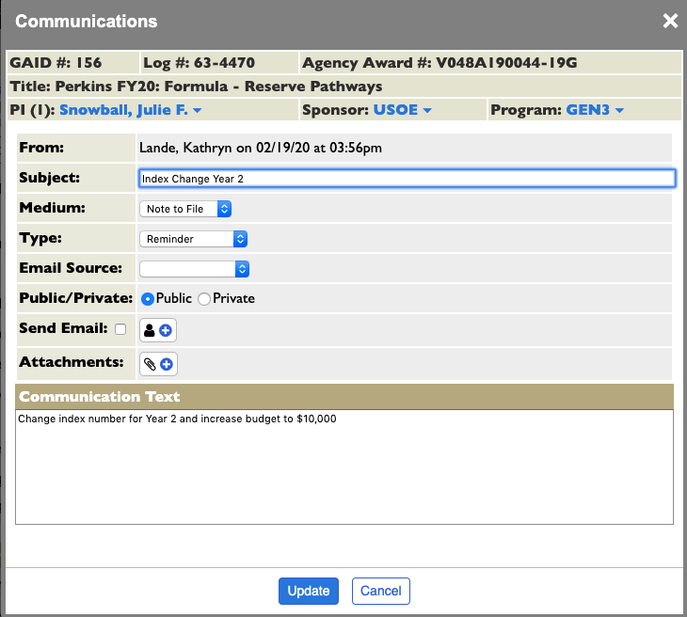

VIEWING COMMUNICATIONS
- In SmartGrant, select relevant award
- On the top menu, select “Communications”

- Select “Edit” icon on left of communication to open, view attachments, print, or delete
