WSU STUDY ABROAD PROGRAM PROPOSAL
For 2017

Name of program:

Starting date:

Ending date:

Destination:

Program director:

Other participating faculty or supervising personnel:

I have attached the following:

Completed program proposal.

Signed Conflict of Interest form for myself and other participating faculty members. Tentative budget sheet.

Completed P-card application (only if this is first time leading a program)
Website Template
Program Leader Contract

___________________________________________________________________________
Program Director Date

By our signatures below, we indicate we have read and approved the attached materials. We also authorize the stated Program Director to travel.

_____________________________________________________________________________________________
Department Chair Date

___________________________________________________________________________

Academic Dean Date

For Study Abroad Office Only

___________________________________ |  | ________________________________________
Study Abroad Director | Date | Dean of International Programs | Date

STUDY ABROAD PROGRAM PROPOSAL

Complete this proposal and submit it to the Study Abroad Office (SS 174).

If you have any questions, contact Study Abroad at (801) 626-8740.

ACADEMIC PROGRAM PROPOSAL

- List the academic courses and the number of credit hours offered for this program.

- Does this course have prerequisites? If so list all prerequisites.

- Is this course offered (1) for general education credit, (2) as a major requirement, (3) or for elective credit?

- Identify specific learning outcomes which students are expected to demonstrate upon completion of the program.

- Briefly describe how the on-site scheduled activities will assist students in achieving the learning outcomes of this Program

- Briefly describe how academic assignments and lectures (before, during and after the trip) will assist students in achieving the learning outcomes of this program

- Briefly describe how students will be evaluated to determine if they have achieved the learning outcomes identified above; provide the detailed criteria to be used in assigning grades.

- Why will this destination provide an excellent experience for students studying this subject?

PERSONNEL

1. Identify the Program Director and any other trip leaders. Describe the trip leader/co-leader responsibilities and their qualifications to fulfill these supervisory responsibilities.

2. Identify the selection criteria to be used with trip participants, including educational background, physical fitness and/or required medical exam. Identify the minimum and maximum size of the group. NOTE: Family members who accompany study abroad programs will be charged the program fee

However, minor children of the trip director or supporting faculty are not allowed on study abroad programs. No participant’s minor children are allowed on any international travel programs for Weber State.

3. What experience does Program Director and/or co-leader have in the destination country?

4. If you are not currently certified, CPR and First-Aid training is highly recommended, and the Study Abroad Office will provide training opportunities. List the date of your most recent CPR and First-Aid training.

  - Will you receive financial compensation for this program? Include in the budget.

Yes No

  - Will you receive a $47 per diem for this program? Include in budget Yes

No

OVERALL PROGRAM DETAILS

- Provide a trip itinerary, including dates for pre-departure orientation, SLC departure and return date, in-country arrival date, de-briefing session, etc.

- Describe the marketing and promotional plans for this program. (Note: The Study Abroad staff will provide items if requested)

- Identify risk management issues (health, safety, liability) which may be unique to the areas being visited; describe how these issues will be effectively addressed in the design of the program.

- Describe management plan, including telephone/email contact information, to be used if problems arise. (CE will provide Emergency Response Training)

WSU STUDY ABROAD PROGRAMS
CONFLICT OF INTEREST DISCLAIMER

Please copy and have every faculty member attending this Study Abroad Program complete this form. For more information on conflicts of interest, please see PPM 3-36.

I hereby certify that I have no actual or potential financial interest or involvement which is, or could be perceived to be, in conflict with the discharge of my duties as a Study Abroad Program Director at Weber State University.

OR

I hereby declare the following to be an actual or potential financial interest or other involvement which is, or could be perceived to be, in conflict with the discharge of my

duties as a Study Abroad Program Director at Weber State University. Further, I propose that these actual or potential conflicts of interest be resolved in the following manner

(describe conflict and proposed resolution below):

____________________________________________________________________________________________

____________________________________________________________________________________________

____________________________________________________________________________________________

____________________________________________________________________________________________

Name:

Title:

Program:

Signature:

Date:

Weber State University Purchasing/Travel Card

Application Form

Please fill out information as it pertains to you: (please type or print)

Name ___________________________________________________________________

Department ________ ____________________________________

Work Extension _____________ Bldg & Room ____________ Mail Code ____________

Mother’s Maiden Name or Password ___________________________________________

Social Security Number _____________________________________________________

Date of Birth (MM/DD/YYYY)_____________________________________________________________

Department Chair ________________________________________________________________________
Dean/Director _________________________________________________________________________________

Vice President _____________________________________________________________

Nineteen-digit FOAPAL (account to be charged) __________________________________

My Reconciler will be ________________________________________________________

Check here to learn how to purchase office supplies at great savings. You can order from your desk, with next day delivery to your office, from our state contractors.

Note: The card limit for purchases will be set at $1500 per transaction with a monthly limit of $5000. The limit for travel will be set at $5000 per transaction with a monthly limit of $5000. ATM is only available for group travel (daily & monthly limit determined by the vice president &

purchasing) and foreign travel (limit for individual not to exceed $100 per day). ATM usage must be pre-authorized by the supervisor and appropriate vice president, prior to each trip.

Limits on the card may be lowered when requested by the department chair or dean/director.
Immediate supervisor’s approval required for (Please check only one)
Purchases only Travel only Purchases & Travel
Immediate Supervisor’s Signature ___________________________________________

(i.e., Dept. Chair, Dean/Dir. or V.P.)

Accounting Services Approval _______________ Purchasing Approval _______________

Please open the actual Budget Excel Spreadsheet made available for your use from the link at the bottom of the page.
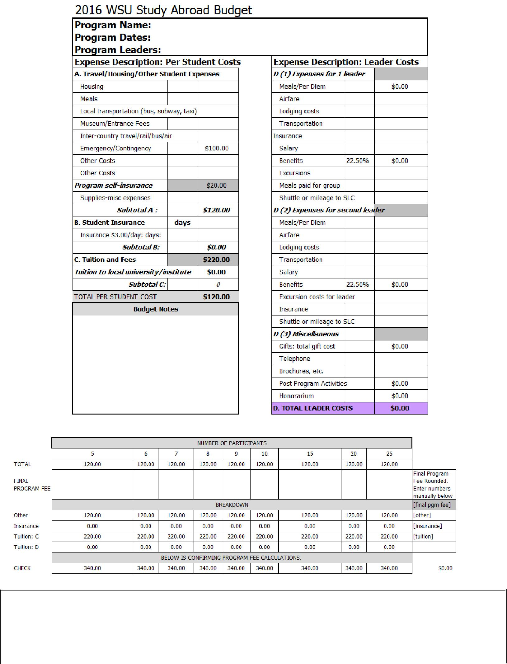

FINAL program fee : based on_____________ of participants

Because Study Abroad programs are self-supporting, I understand that the per diem and or salary may be modified due to insufficient enrollment or other program expenses that must be paid first.

I agree to the budget for my program: ___________________________________________________ Date:________________________________________

Approved by: ________________________________________________________________________ Date:________________________________________

Open the Study Abroad Excel Worksheet

NOTE: Students cannot sign up for Payment Plans for Study Abroad Programs. All programs need to be paid in full before each trip leaves.
