GEOGRAPHY CLUB

Care for the environment around you and want to make a difference while having fun? Then you have found the Club that makes that happen!

**Bike Rack Service** Project/Fundraiser
Raise Funds to Purchase Bike Racks for Ogden Preparatory Academy.

Goal: Raise $1,000 by August 2013
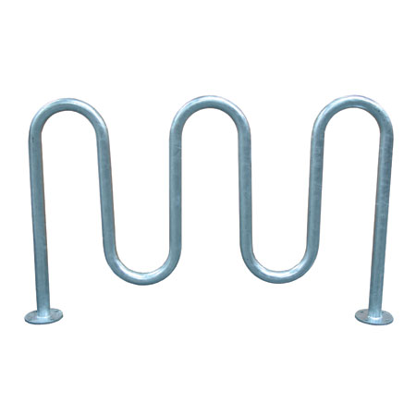

*All other service opportunities will be through the Community Involvement Center
What to Expect Spring 2013!
- Jan. 14th Bring Your Own Mug Day!
  - Hot Chocolate/Coffee discounted if you bring your own mug.
  - Other Breakfast Items for Sale
  - Will happen first Monday of every month after that!!!
- Jan. 16th Next Club Mtg.
- Jan. 25th Opening Social
  - Club Presentation & Dr. Julie Rich reports on her sabbatical trips!
- Feb. 6th Major Fest
- More activities to come!

Faculty Advisor: Dr. Julie Rich (jrich@weber.edu) Geography Department
President: Robert Winn (rwinn@mail.weber.edu) Social Science Building (SS) Rm 314
Vice President: Hannah Rice (hannahrice@mail.weber.edu) Geography Dept Ph. (801) 626-6207
Vice President: Brittney Parker (ba_parker@hotmail.com) http://www.facebook.com/#!/groups/346339745394076/ Vice President: Ray Tripp (rtripp@mail.weber.edu) http://www.weber.edu/geography/

